



**Clinic Management System**

IST 659

**Group 3**

Sonamgyalpo Sherpa

Praneshwar Srinivasan

Neel Samant

**Table of Contents**

|  |  |  |
| --- | --- | --- |
| **Sr. no.** | **Title** | **Page no.** |
| 1. | Project Summary | 3 |
| 2. | Entity and Attributes table | 4 |
| 3. | Entity Relationship diagram | 10 |
| 4. | Creation of Tables | 11 |
| 5. | Inserting Data | 21 |
| 6. | Major Data Questions | 27 |
| 7. | Interfaces | 30 |
| 8. | Procedure | 36 |
| 9. | Trigger | 37 |
| 10. | Reports | 40 |

**Project Summary**

Our project focusses on the creation of a Database for hospital administration to manage its records of Doctors, Patients, clinics as well as the Medicines prescribed in the clinics that are situated in various regions, which will allow the doctors to efficiently keep track of the patients as well as patients to find the nearest clinic as well as the available medicines. How can the administration efficiently manage the records? How can the patients easily get the information about the availability of medicines in the stores? How can the doctors keep track of the current health of their patients? Our project aims to create a system that answers the above questions and more.

Our system will be consisting of a Database having all the information about the Doctors working for the hospital, the dynamic data of the patients visiting the hospital, the clinics (branches of the hospital), the departments that each of the clinics consist of and the medicines available in the clinics as well as those prescribed by the doctors to their patients. We will be designing portals for the doctors, patients and the administration which will serve their respective purposes.

The entities that are a part of our database have irregular volumes of data. For example, there are just a few departments in the hospital but on the other hand, there are a huge number of patients. Our goal is to improve the User experience between all the users of this system as they can easily interact online and exchange information. The patients can easily query the system to look for the nearest clinics based on the location as well as the availability of a certain department in that clinic. The system will also help the administration to keep a track of all the stakeholders in the Hospital.

As most of the hospitals and medical institutions still prefer physical records to this day, there is an issue of loss of data as well as wastage of space. By using our system, this issue can be easily rectified as the data stored in an electronic form is less prone to data loss. Furthermore, patients find it difficult to locate the nearest clinics with a doctor that can address their issues. It is also impossible to check for the availability of the drugs prescribed to them in the medical stores. With the creation of the patient portal, all these issues can be easily avoided. Physical records also restrict the doctor from effectively keeping track of their patients which may result in dire consequences for the patients. The doctors also find it extremely difficult to keep track of the drugs prescribed to the patients. In short, our system will help to automate the operation of a Medical institute and make it convenient for all the entities involved.

The design report that we have made, consists of the basic summary of the system that we have designed, its functions and objectives as well as the information of all the entities and their attributes that have been considered for the project. We have also constructed the Entity relationship diagram showing the relationships and the dependencies of various entities in the system. Furthermore, we have also stated all the business rules that have not been specified in the ER diagram. Finally, we have stated all the major questions that could be answered by using our system as well as those that could still be left unanswered.

**Entity and Attributes table**

|  |  |  |  |  |
| --- | --- | --- | --- | --- |
| **Entity Name: Patient** | **Attribute Name** | **Field Type** | **NULL/NOT NULL** | **Explanation** |
| Primary Key | ID | int | NOT NULL | Unique / Primary Key identifier of the “Patient” entity |
| Other Attributes | Name | Char(50) | NOT NULL | Name of the Patient |
|  | Age | int | NOT NULL | Age of the Patient |
|  | Address | Varchar(60) | NULL | Address of the Patient |
|  | City | Char(20) | NULL | City in which the patient presently resides |
|  | Email_ID | Varchar(60) | NOT NULL | Email – ID with which the Patient has registered with the Hospital |
|  | Phone_No | int | NOT NULL | Phone Number of the patients |

1. **Patient:** Entity which describing the attributes of the patients that come into all clinics across the regions
2. **Patient_Loc:** Associate entity showing the location of the Patient

|  |  |  |  |  |
| --- | --- | --- | --- | --- |
| **Entity Name: Patient_Loc** | **Attribute Name** | **Field Type** | **NULL/NOT NULL** | **Explanation** |
| Primary Key, Foreign Key | ID | int | NOT NULL | Unique Identifier of Patient |
| Other Attribute | Zip | int | NOT NULL | Zip code of the area in which Patient resides |

1. **Doctor:** The entity which describes the attributes of the doctors employed in all clinics across the regions

|  |  |  |  |  |
| --- | --- | --- | --- | --- |
| **Entity Name: Doctor** | **Attribute Name** | **Field Type** | **NULL/NOT NULL** | **Explanation** |
| Primary Key | ID | int | NOT NULL | Unique/Primary Key identifier of the “Doctor” entity. |
| Primary Key | Email ID | Varchar(30) | NOT NULL | Work Email id of the Doctor |
| Other Attributes | Experience | int | NOT NULL | No. of Years of experience in the field for the Doctor |
|  | Designation | Char(50) | NOT NULL | Designation/title of the doctor |
|  | Name | Char(30) | NOT NULL | Name of the Doctor |
|  | Phone_No | int | NULL | Work Phone Number of the Doctor |
| Foreign Key | Department | int | NOT NULL | Foreign key linked to the department table |

1. **Clinic:** Entity describing the clinics that the doctors and medicines are in and where the patients can go into

|  |  |  |  |  |
| --- | --- | --- | --- | --- |
| **Entity Name: Clinic** | **Attribute Name** | **Field Type** | **NULL/NOT NULL** | **Explanation** |
| Primary Key | ID | int | NOT NULL | Unique / Primary key of the “clinic” entity |
| Other Attributes | City | Char(20) | NOT NULL | City in which the clinic is situated |
|  | URL | Varchar(50) | NOT NULL | The website of the clinic |
|  | Name | Char(30) | NOT NULL | Name of the clinic |

1. **Clinic_Loc:** Associate entity showing the location of the clinic

|  |  |  |  |  |
| --- | --- | --- | --- | --- |
| **Entity Name: Clinic_Loc** | **Attribute Name** | **Field Type** | **NULL/NOT NULL** | **Explanation** |
| Primary Key, Foreign Key | ID | int | NOT NULL | Unique / Primary key of the “clinic” entity |
| Other Attribute | Zip | int | NOT NULL | Zip code of the area in which Clinic is |

1. **Department:** Entity describing the different departments in each clinic and which has a number of doctors assigned to them.

|  |  |  |  |  |
| --- | --- | --- | --- | --- |
| **Entity Name: Department** | **Attribute Name** | **Field Type** | **NULL/NOT NULL** | **Explanation** |
| Primary Key | ID | int | NOT NULL | Unique/Primary Key of the “Department” entity |
| Other Attributes | Name | Char(50) | NOT NULL | Name of the department |
|  | Department_Head | Char(30) | NOT NULL | The head of the department in charge of the department |
|  | Email_ID | Varchar(30) | NOT NULL | The office email id of the department |
|  | Phone_No | int | NOT NULL | The office Phone number of the department. |

1. **Medicine:** Entity describing the medicines that are available in each store.

|  |  |  |  |  |
| --- | --- | --- | --- | --- |
| **Entity Name: Medicine** | **Attribute Name** | **Field Type** | **NULL/NOT NULL** | **Explanation** |
| Primary Key | ID | int | NOT NULL | Unique/Primary identifier of the “Medicine” entity |
| Other Attributes | Name | Char(50 | NOT NULL | Name of the medicine |
|  | Quantity | int | NOT NULL | Quantity of the Medicine in the inventory |
|  | Medicine_Type | Varchar(10) | NOT NULL | The type of the medicine |

1. **Medicine_Dept:** Entity showing to which department does the medicine belong

|  |  |  |  |  |
| --- | --- | --- | --- | --- |
| **Entity Name: Medicine_Dept** | **Attribute Name** | **Field Type** | **NULL/NOT NULL** | **Explanation** |
| Primary Key, Foreign Key | ID | int | NOT NULL | Entity describing the medicines that are available in each store. |
| Primary Key, Foreign Key | Med_Dept | int | NOT NULL | Dept. related to the Medicine |

1. **Appointment:** Associate table which links doctor and patient in order to schedule an appointment

|  |  |  |  |  |
| --- | --- | --- | --- | --- |
| **Entity Name: Appointment** | **Attribute Name** | **Field Type** | **NULL/NOT NULL** | **Explanation** |
| Primary Key | ID | int | NOT NULL | ID of Appointment |
| Other Attributes | Doc_Name | Char(30) | NOT NULL | Name of the Doctor tending |
|  | Patient_Name | Char(30) | NOT NULL | Name of the Patient |
|  | Patient_issue | Varchar(50) | NOT NULL | Issue faced by Patient |
|  | Appointment_Time | datetime | NOT NULL | Appointment time specified |
| Foreign Key | Doc_ID | int | NOT NULL | ID of Doctor |
| Foreign Key | Doc_Email | Varchar(30) | NOT NULL | Email-ID of the Docor |
| Foreign Key | Patient_ID | int | NOT NULL | ID of Patient |

1. **Prescription:** Associate table which links the doctor, patient and Medicine

|  |  |  |  |  |
| --- | --- | --- | --- | --- |
| **Entity Name: Prescription** | **Attribute Name** | **Field Type** | **NULL/NOT NULL** | **Explanation** |
| Primary Key | ID | int | NOT NULL | ID of the Prescription |
| Other Attributes | Doc_Name | Char(30) | NOT NULL | Name of the Doctor prescribing |
|  | Patient_Name | Char(30) | NOT NULL | Name of the Patient |
|  | Patient_issue | Varchar(50) | NOT NULL | Issue faced by Patient |
|  | Medicine_Name | Char(30) | NOT NULL | Name of the medicine prescribed |
|  | Appointment_Time | datetime | NOT NULL | Appointment time specified |
| Foreign Key | Doc_ID | int | NOT NULL | ID of the doctor |
| Foreign Key | Doc_Email | Varchar(30) | NOT NULL | Email-ID of the Doctor |
| Foreign Key | Patient_ID | int | NOT NULL | ID of the Patient |
| Foreign Key | Medicine_ID | int | NOT NULL | ID of the Medicine |

**Entity-Relationship Diagram**

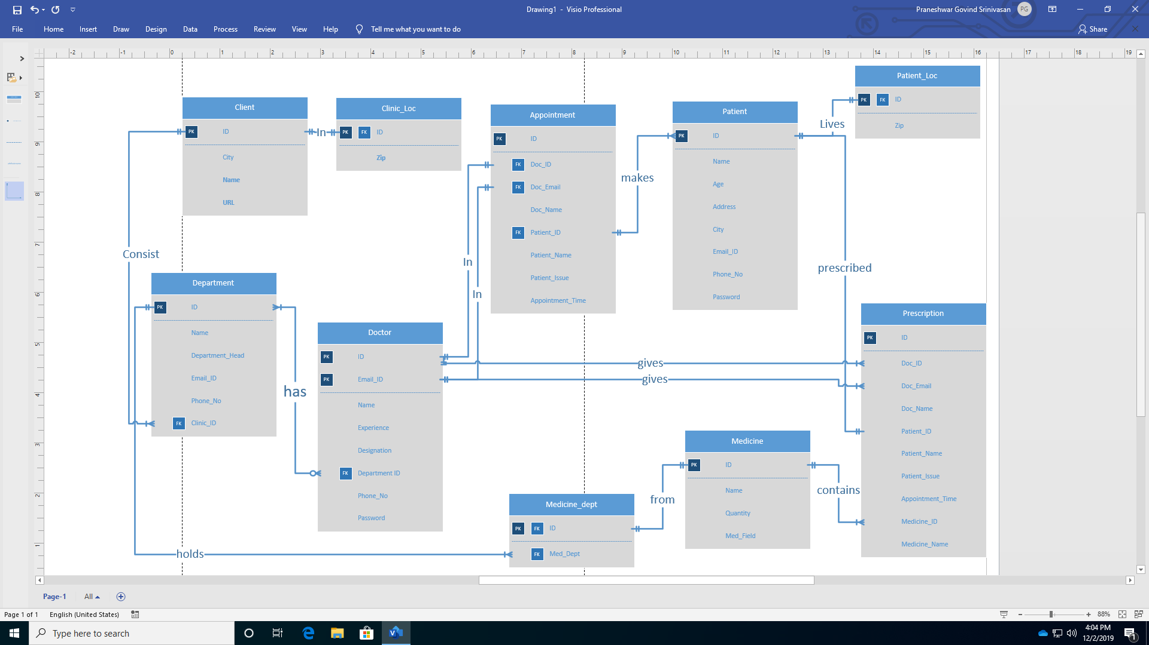

**Creation of Tables**

-- Patient Table

CREATE TABLE Patient(

ID int PRIMARY KEY not null,

Name char(50) not null,

Age int not null,

Address varchar(60),

City char(20),

Email_ID varchar(30) not null,

Phone_No int not null,

);

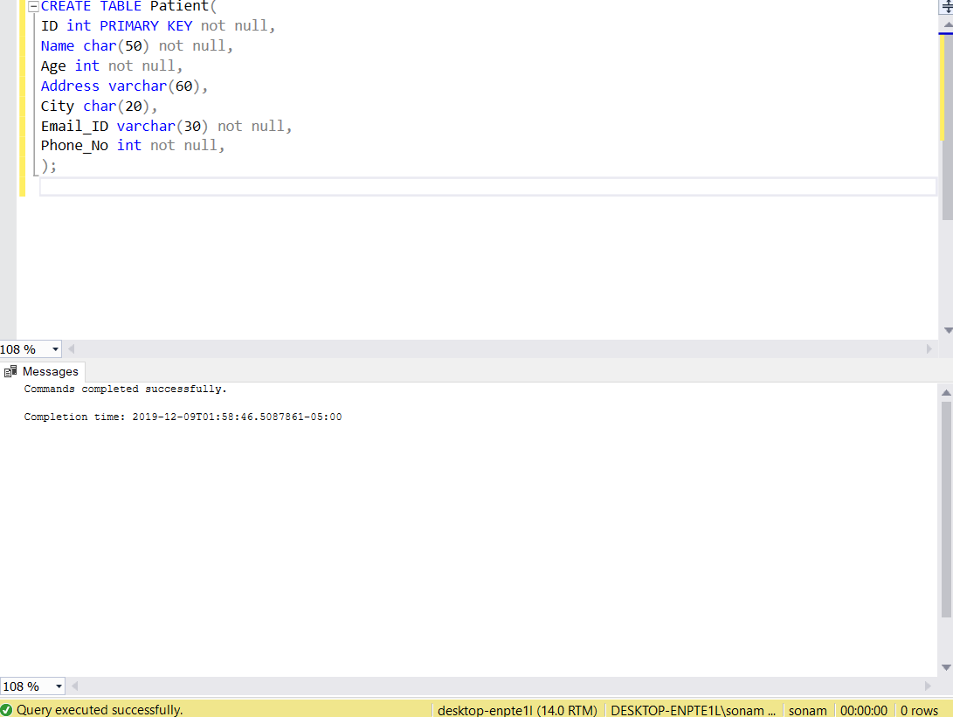

-- Patient Location Table

CREATE TABLE Patient_Loc(

ID int not null,

Zip int not null,

CONSTRAINT PatientLocation_ID FOREIGN KEY (ID) References Patient(ID)

);

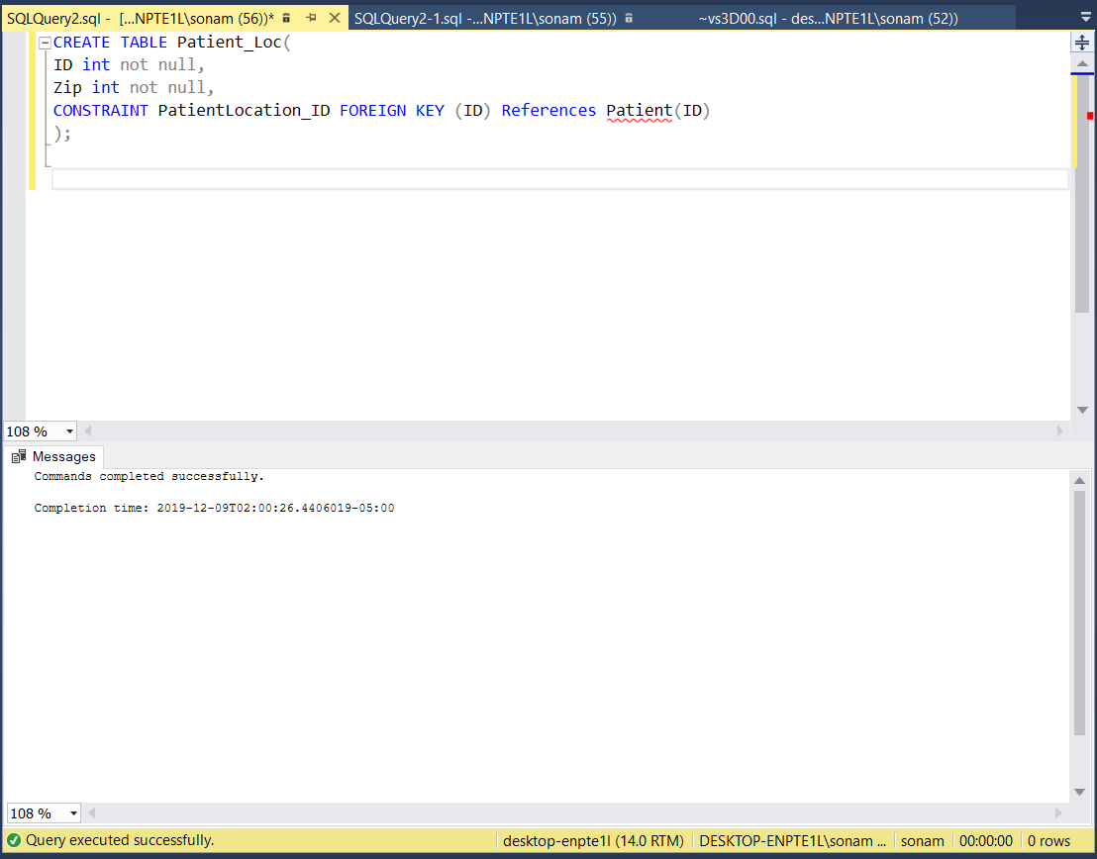

-- Doctor Table

CREATE TABLE Doctor (

ID int not null,

Name char(30) not null,

Experience int not null,

Designation char(50) not null,

Department int not null,

Email_ID varchar(30) not null,

Phone_No int,

CONSTRAINT Doc_ID PRIMARY KEY (ID,Email_ID),

CONSTRAINT DepID FOREIGN KEY (Department) References Department(ID)

);

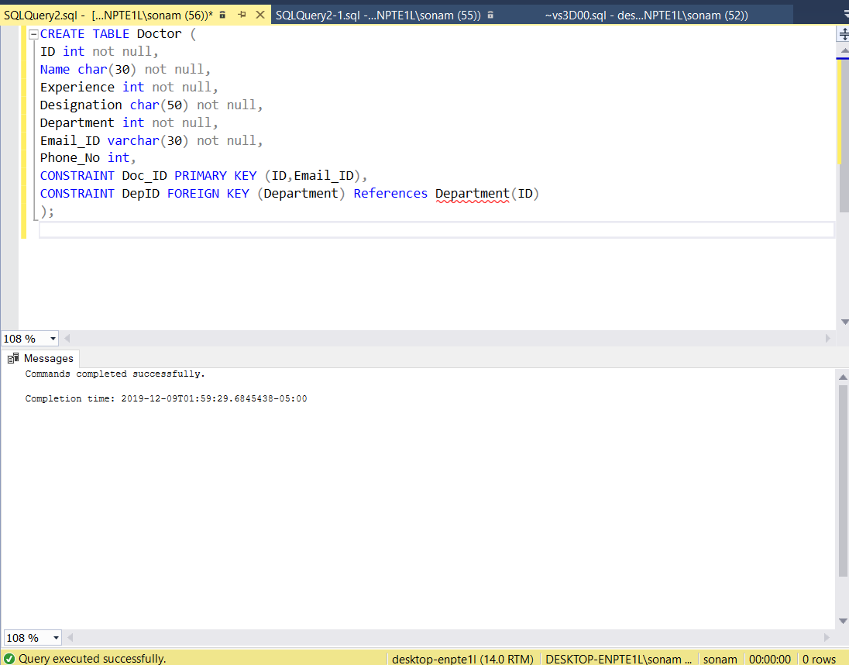

-- Clinic Table

CREATE TABLE Clinic(

ID int PRIMARY KEY not null,

City char(20) not null,

URL varchar(50) not null,

Name char(30) not null,

);

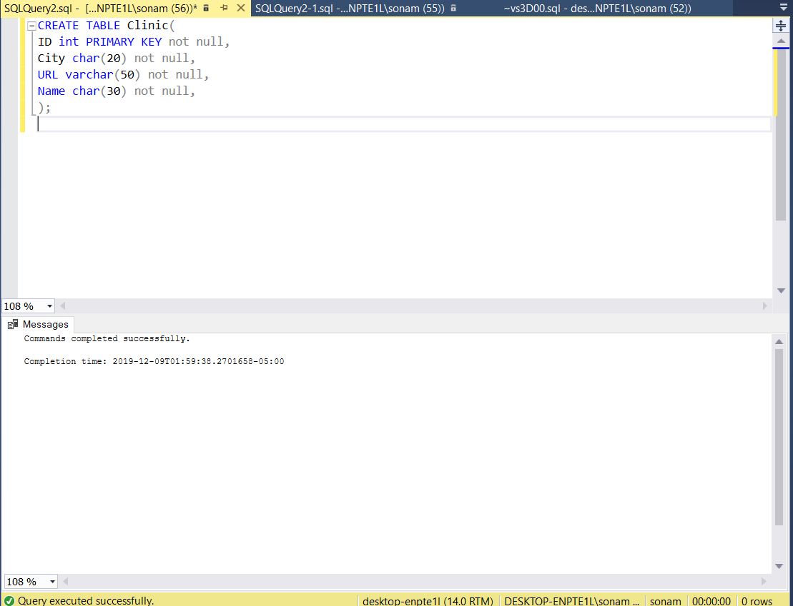

-- Clinic Location Table

CREATE TABLE Clinic_Loc(

ID int PRIMARY KEY not null,

Zip int not null,

CONSTRAINT ClinicID FOREIGN KEY (ID) References Clinic(ID)

);

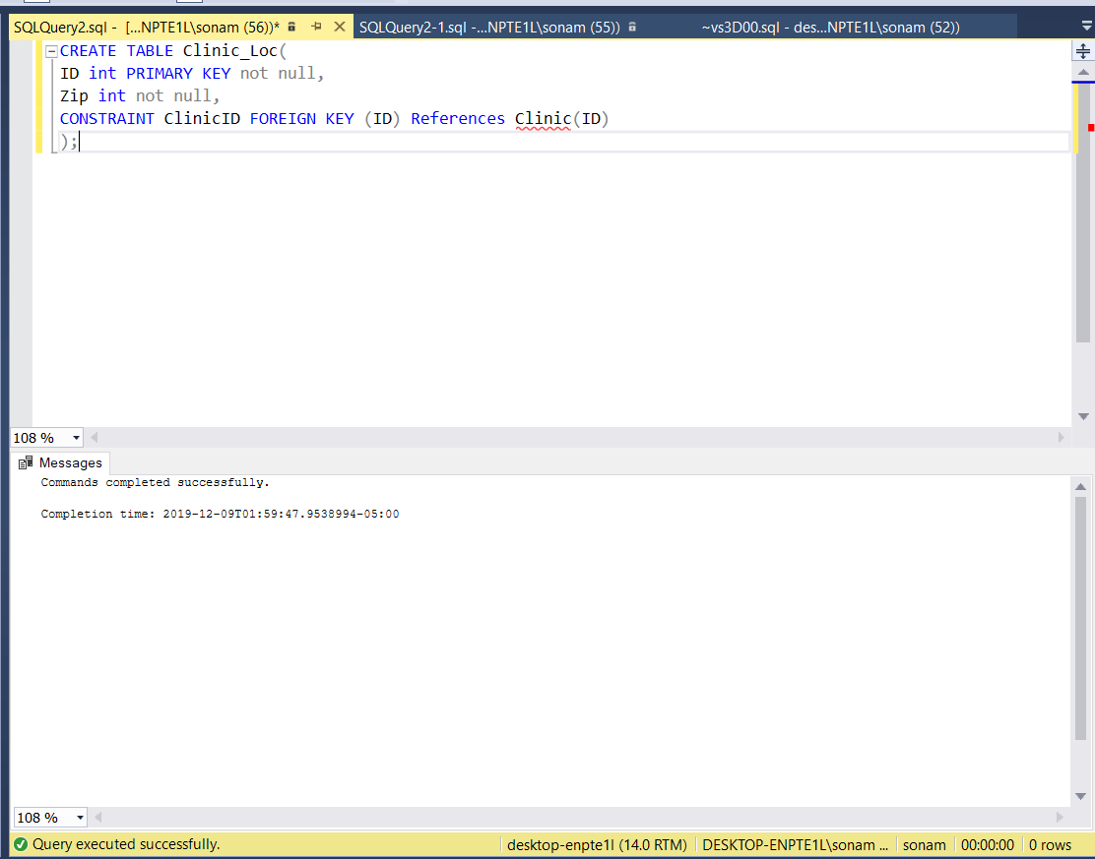

-- Department Table

CREATE TABLE Department(

ID int PRIMARY KEY not null,

Name char(50) not null,

Department_Head char(30),

Email_ID varchar(30) not null,

Phone_No int not null

);

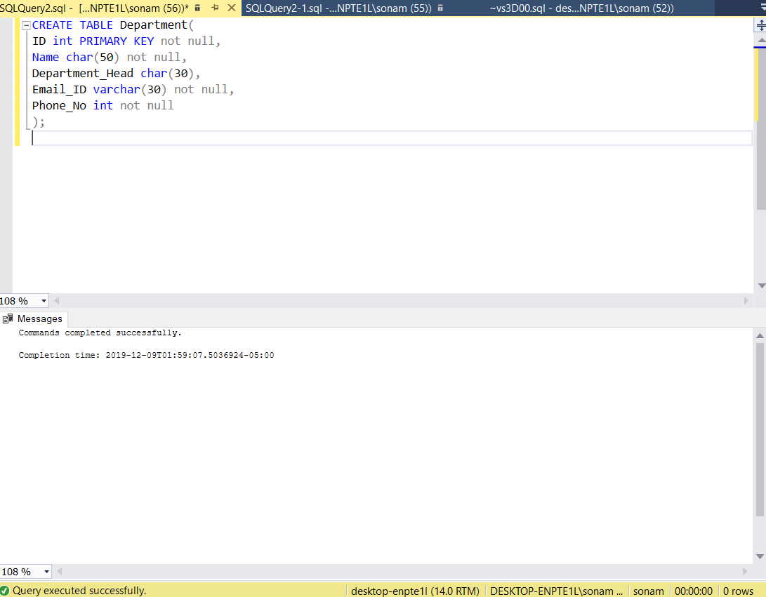

--Medicine Table

CREATE TABLE Medicine(

ID int PRIMARY KEY not null,

Name char(50) not null,

Quantity int not null,

Medicine_Type varchar(10) not null check(Medicine_Type in ('Liquid','Tablet','Capsule'))

);

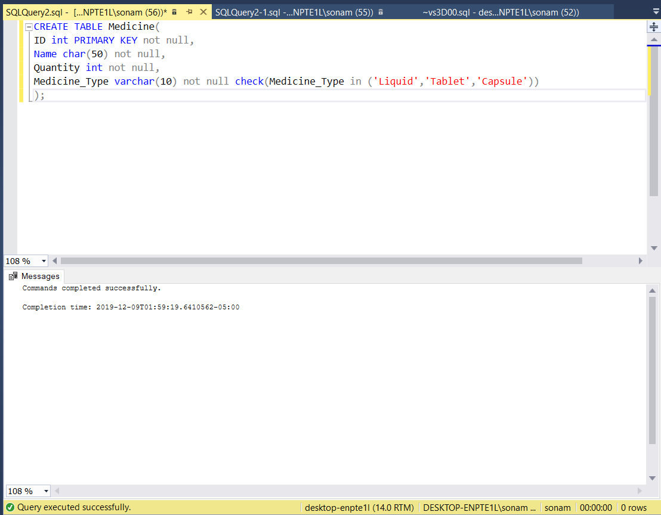

-- Medicine Department Table

CREATE TABLE Medicine_dept(

ID int not null,

Med_Dept int not null,

PRIMARY KEY("ID","Med_Dept"),

CONSTRAINT MedicineID FOREIGN KEY (ID) References Medicine(ID),

CONSTRAINT Med_dept_ID FOREIGN KEY (Med_Dept) References Department(ID)

);

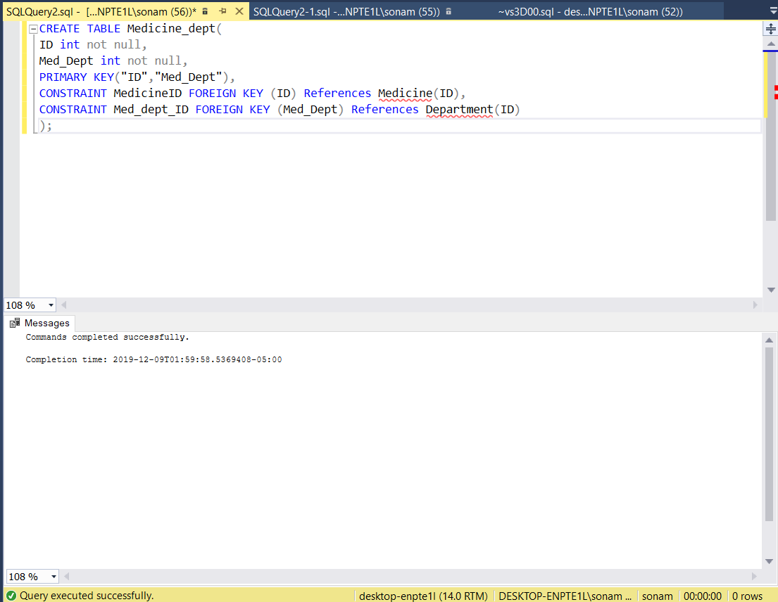

-- Appointment Table

CREATE TABLE Appointment(

ID int PRIMARY KEY not null,

Doc_ID int not null,

Doc_Email varchar(30) not null,

Doc_Name char(30) not null,

Patient_ID int not null,

Patient_Name char(30) not null,

Patient_issue varchar(50) not null,

Appointment_Time datetime not null,

CONSTRAINT Doctor_ID FOREIGN KEY (Doc_ID,Doc_Email) References Doctor(ID,Email_ID),

CONSTRAINT PatientID FOREIGN KEY (Patient_ID) References Patient(ID)

);

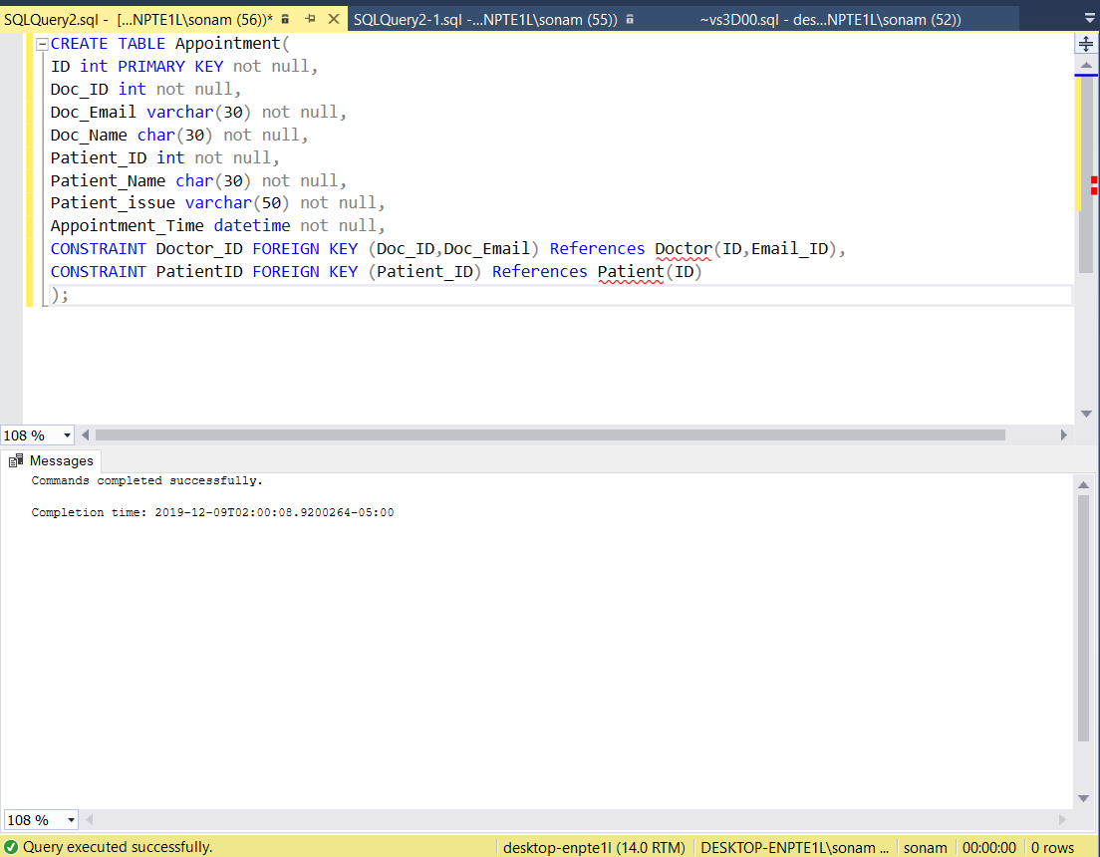

-- Prescription Table

CREATE TABLE Prescription(

ID int PRIMARY KEY not null,

Doc_ID int not null,

Doc_Email varchar(30) not null,

Doc_Name char(30) not null,

Patient_ID int not null,

Patient_Name char(30) not null,

Patient_issue varchar(50) not null,

Appointment_Time datetime not null,

Medicine_ID int not null,

Medicine_Name char(20) not null,

CONSTRAINT DoctorID FOREIGN KEY (Doc_ID,Doc_Email) References Doctor(ID,Email_ID),

CONSTRAINT Patient_ID FOREIGN KEY (Patient_ID) References Patient(ID),

CONSTRAINT Medicine_ID FOREIGN KEY (Medicine_ID) References Medicine(ID)

);

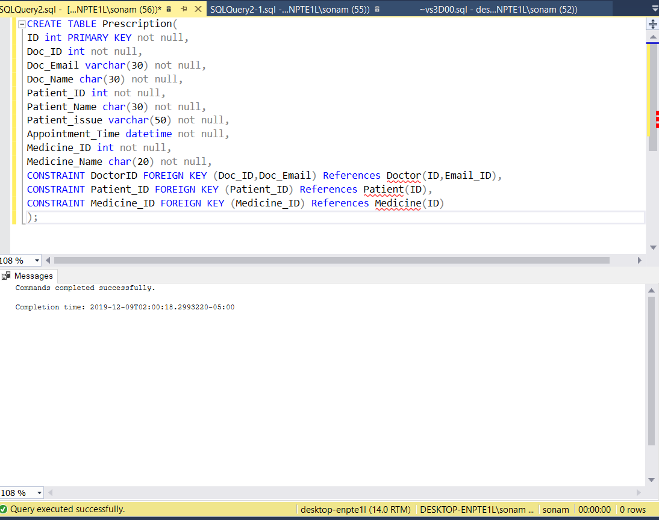

**Inserting Values**

-- Insert into PATIENT

INSERT INTO Patient

VALUES

(1,'Sachin Tendulkar',40,'1524 E Genesee Str','Syracuse','st@gmail.com',347864256),

(2,'Ronaldo',35,'234 Lanchaster Str','Syracuse','rn07@gmail.com',347864527),

(3,'Andrew Lawson',65,'431 University Str','Syracuse','al@gmail.com',347879468),

(4,'Mohammed Hussien',48,'1234 Columbus Avenue','Syracuse','mh@gmail.com',347859879),

(5,'Richard Parker',58,'465 Kings Road Pk','Seattle','rip@gmail.com',347844561),

(6,'Jill Simpsons',35,'5 Prince Road Pk','Seattle','js@gmail.com',347834652),

(7,'Harmeet Singh',47,'10 Vaziers Road Pk','Seattle','hs@gmail.com',347868253),

(8,'Sarrah Conners',26,'477 Destiny Road Pk','Seattle','sc@gmail.com',347587984),

(9,'Jnow Snow',67,'Richy Street Avenue','Binghamton','jos@gmail.com',347441475),

(10,'Abhishek Patil ',67,'Villanova Street Avenue','Binghamton','ap@gmail.com',347846556),

(11,'Patil Rohit',67,'Franklin Street Avenue','Binghamton','paro@gmail.com',347833267),

(12,'Sonam Patil',67,'James Street Avenue','Binghamton','sop@gmail.com',347879318)

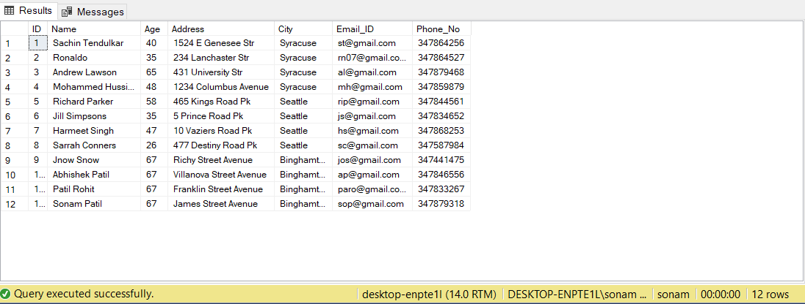

-- Insert into Patient Loc

INSERT INTO Patient_Loc

VALUES

(1,12378),

(2,12334),

(3,12374),

(4,12309),

(5,23412),

(6,23432),

(7,23465),

(8,23474),

(9,34545),

(10,34590),

(11,34562),

(12,34573)

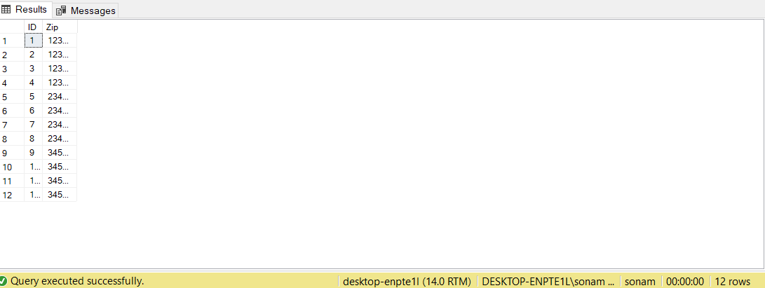

-- Insert into DOCTOR

INSERT INTO Doctor

VALUES

(1,'Harry Putter',12,'Senior Doctor',2,'hpu@2.cu.com',568749125),

(2,'Gabriel Adam',3,'Junior Doctor',3,'ga@3.cu.com',568743221),

(3,'Eve Adams',15,'Senior Doctor',5,'ea@5.cu.com',568747893),

(4,'Mikhael Saint',24,'Senior Doctor',3,'msa@6.cu.com',568747123),

(5,'Angelica Arnold',8,'Associate Doctor',1,'aa@1.cu.com',568753137),

(6,'Jessy James',11,'Associate Doctor',4,'jj@4.cu.com',568741953),

(7,'Lucifer Demon',18,'Senior Doctor',2,'ld@2.cu.com',568744651),

(8,'Caly Jack',6,'Junior Doctor',5,'cj@5.cu.com',568748794),

(9,'Edwards Desmond',17,'Senior Doctor',3,'edw@3.cu.com',568747986),

(10,'Victoria Virginia',21,'Senior Doctor',5,'vv@6.cu.com',568747256),

(11,'Julie Michaels',10,'Associate Doctor',4,'jum@4.cu.com',568755555),

(12,'Hi Jon Moon',9,'Associate Doctor',1,'hjm@1.cu.com',568749448)

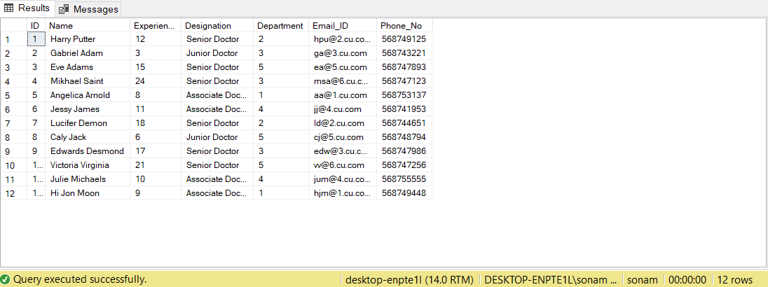

-- Insert into CLINIC

INSERT INTO Clinic

VALUES

(1,'Syracuse','https:/www.cu.syr.com','St.Peters'),

(2,'Seattle','https:/www.cu.sea.com','St.Michaels'),

(3,'Binghamton','https:/www.cu.bin.com','St.George')

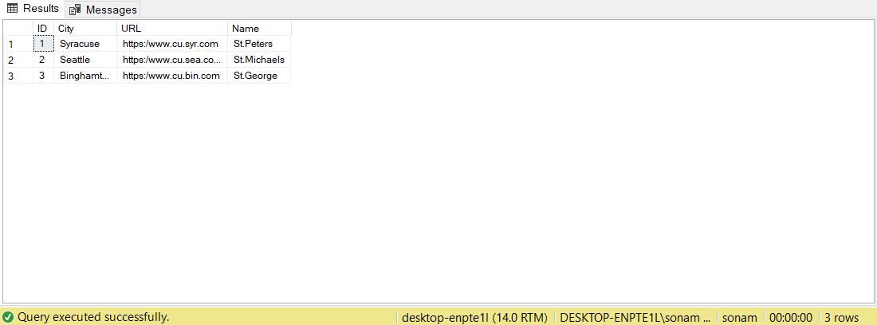

-- Insert into Clinic_Loc

INSERT INTO Clinic_Loc

VALUES

(1,12345),

(2,23489),

(3,34599)

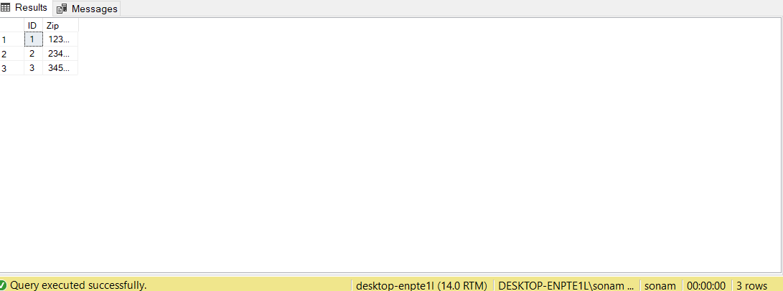

-- Insert into DEPARTMENT

INSERT INTO Department

VALUES

(1,'Cardiology','Abhishek Brewster','abp@ch.com',343254546),

(2,'Radiology','Matthew John','mj@ch.com',343251543),

(3,'Neurology','Rohit Patil','rp@ch.com',347854562),

(4,'Psychology','Sonam Sherpa','ss@ch.com',545432167),

(5,'Paediatrician','Peter George','pg@ch.com',343423445)

-- Insert into Medicines

INSERT INTO Medicine

VALUES

(1,'warfarin',50,'Tablet'),

(2,'heparin',50,'Capsule'),

(3,'epinephrine',50,'Capsule'),

(4,'diphenhydramine',50,'Capsule'),

(5,'Phenytoin',50,'Tablet'),

(6,'Eslicarbazepine ',50,'Tablet'),

(7,'Zoloft',50,'Liquid'),

(8,'Xanax',50,'Tablet'),

(9,'Amoxicillin',50,'Capsule'),

(10,'Albuterol',50,'Liquid')

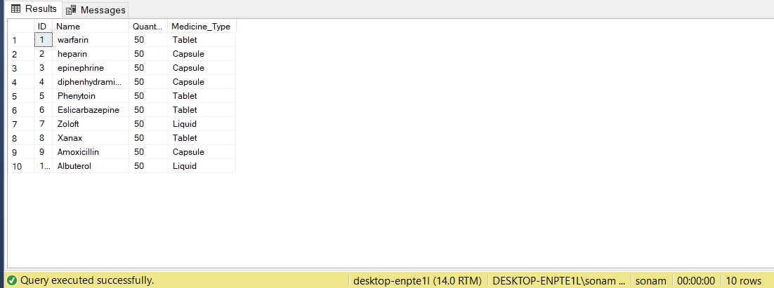

-- Insert into MEDICINE_DEPT

Insert Into Medicine_dept

Values

(1,1),

(2,1),

(3,2),

(4,2),

(5,3),

(6,3),

(7,4),

(8,4),

(9,5),

(10,5)

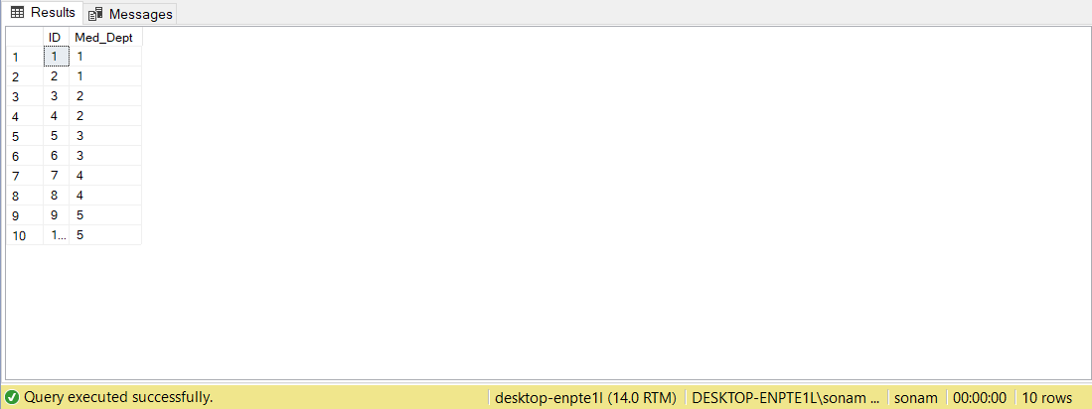

**Major Data Questions**

1. Select a specific medicine type in a medicine.

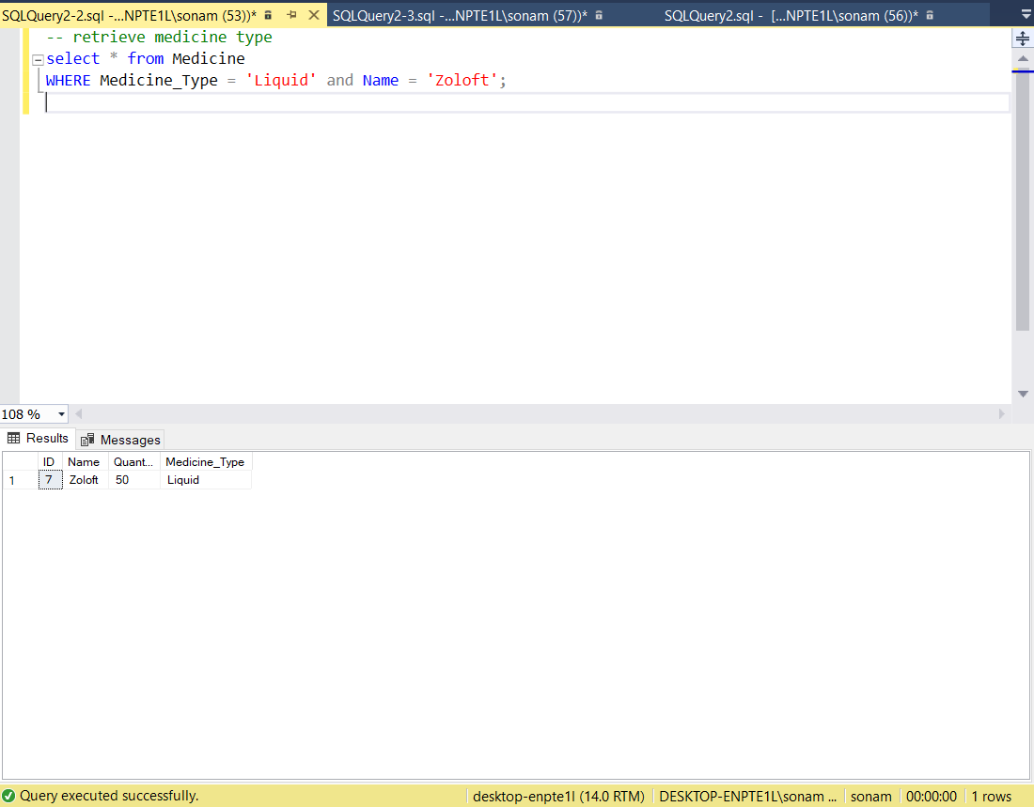

1. How do you find a doctor with respect to his department?

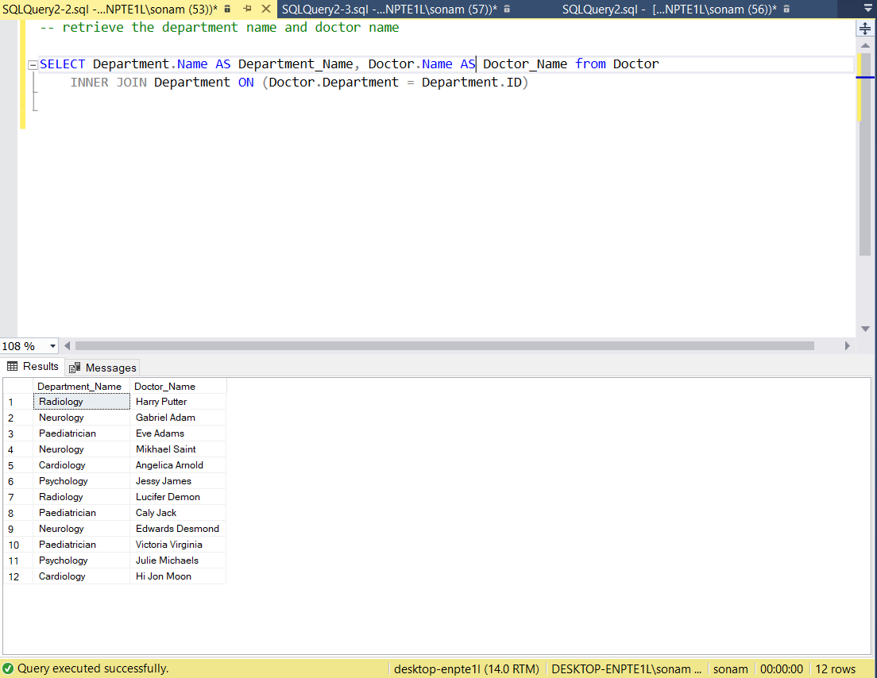

1. How can you find the location of a clinic in a city?

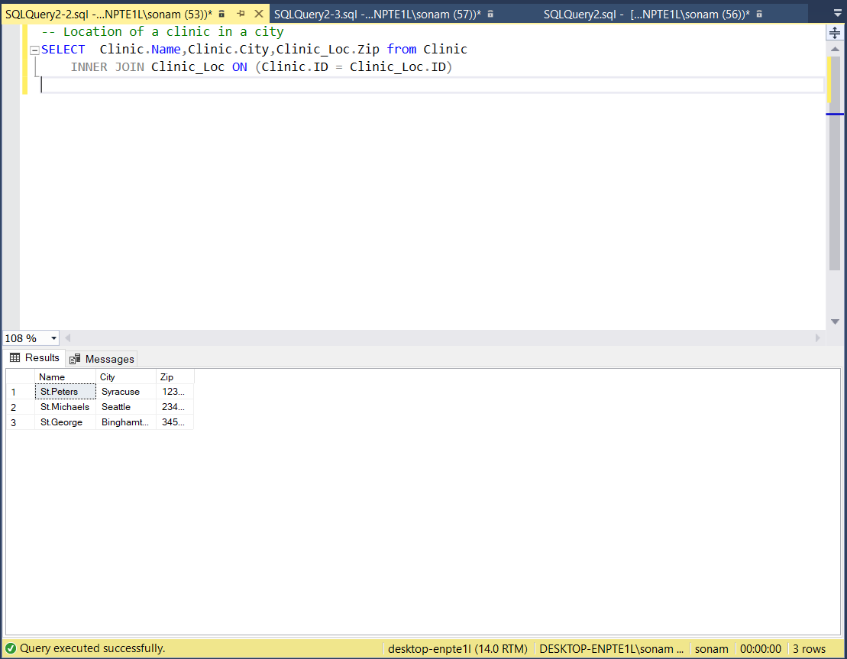

1. How to find the number of doctors in a department?

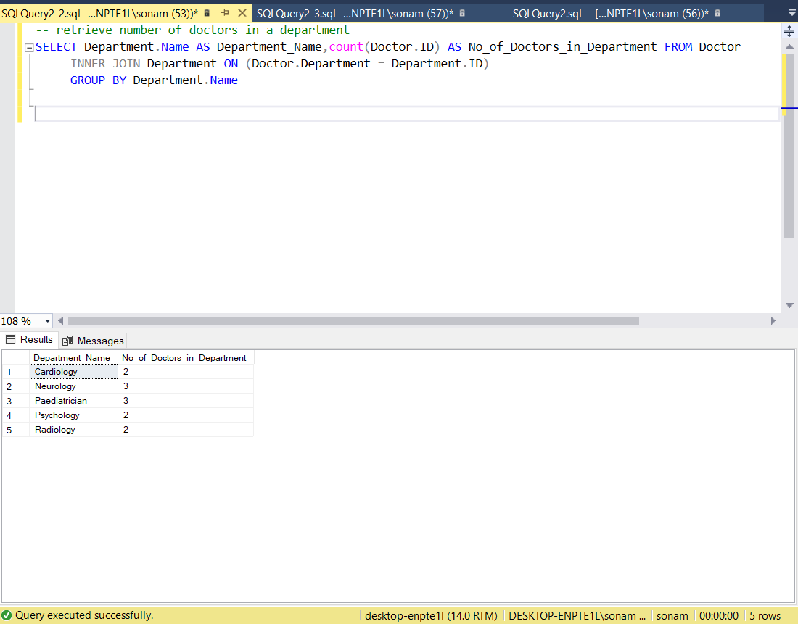

1. How to retrieve patient’s details treated by a doctor?

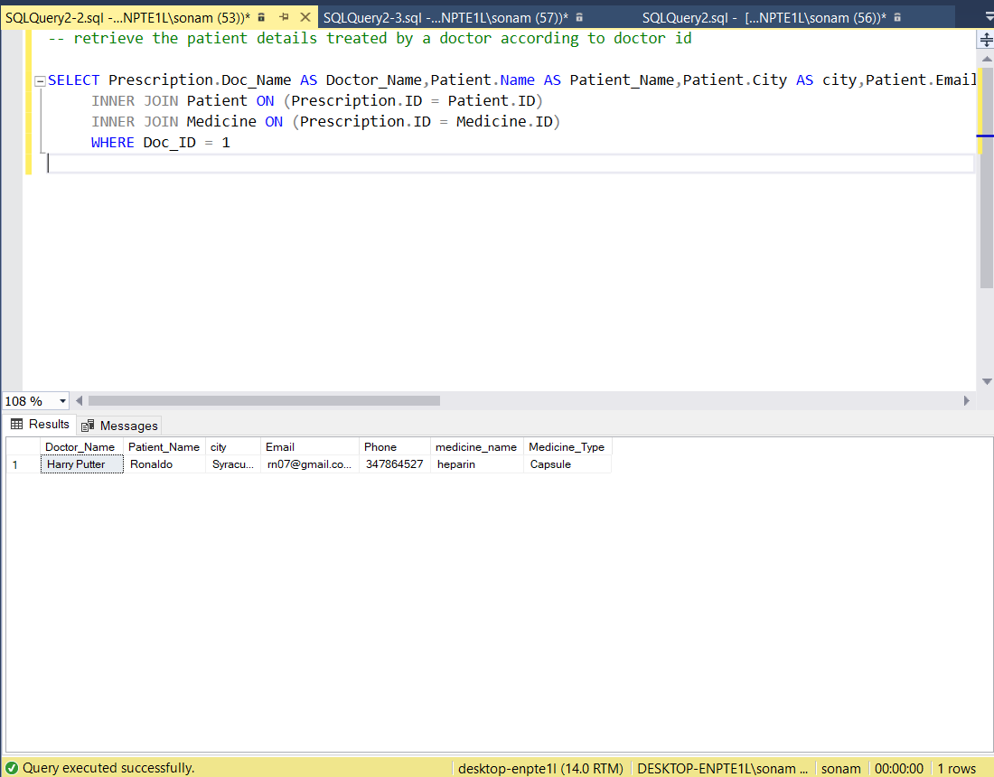

**Interface**

There are 3 types of log in possible. They are:

* Patient Login
* Doctor Login
* Administrator Login

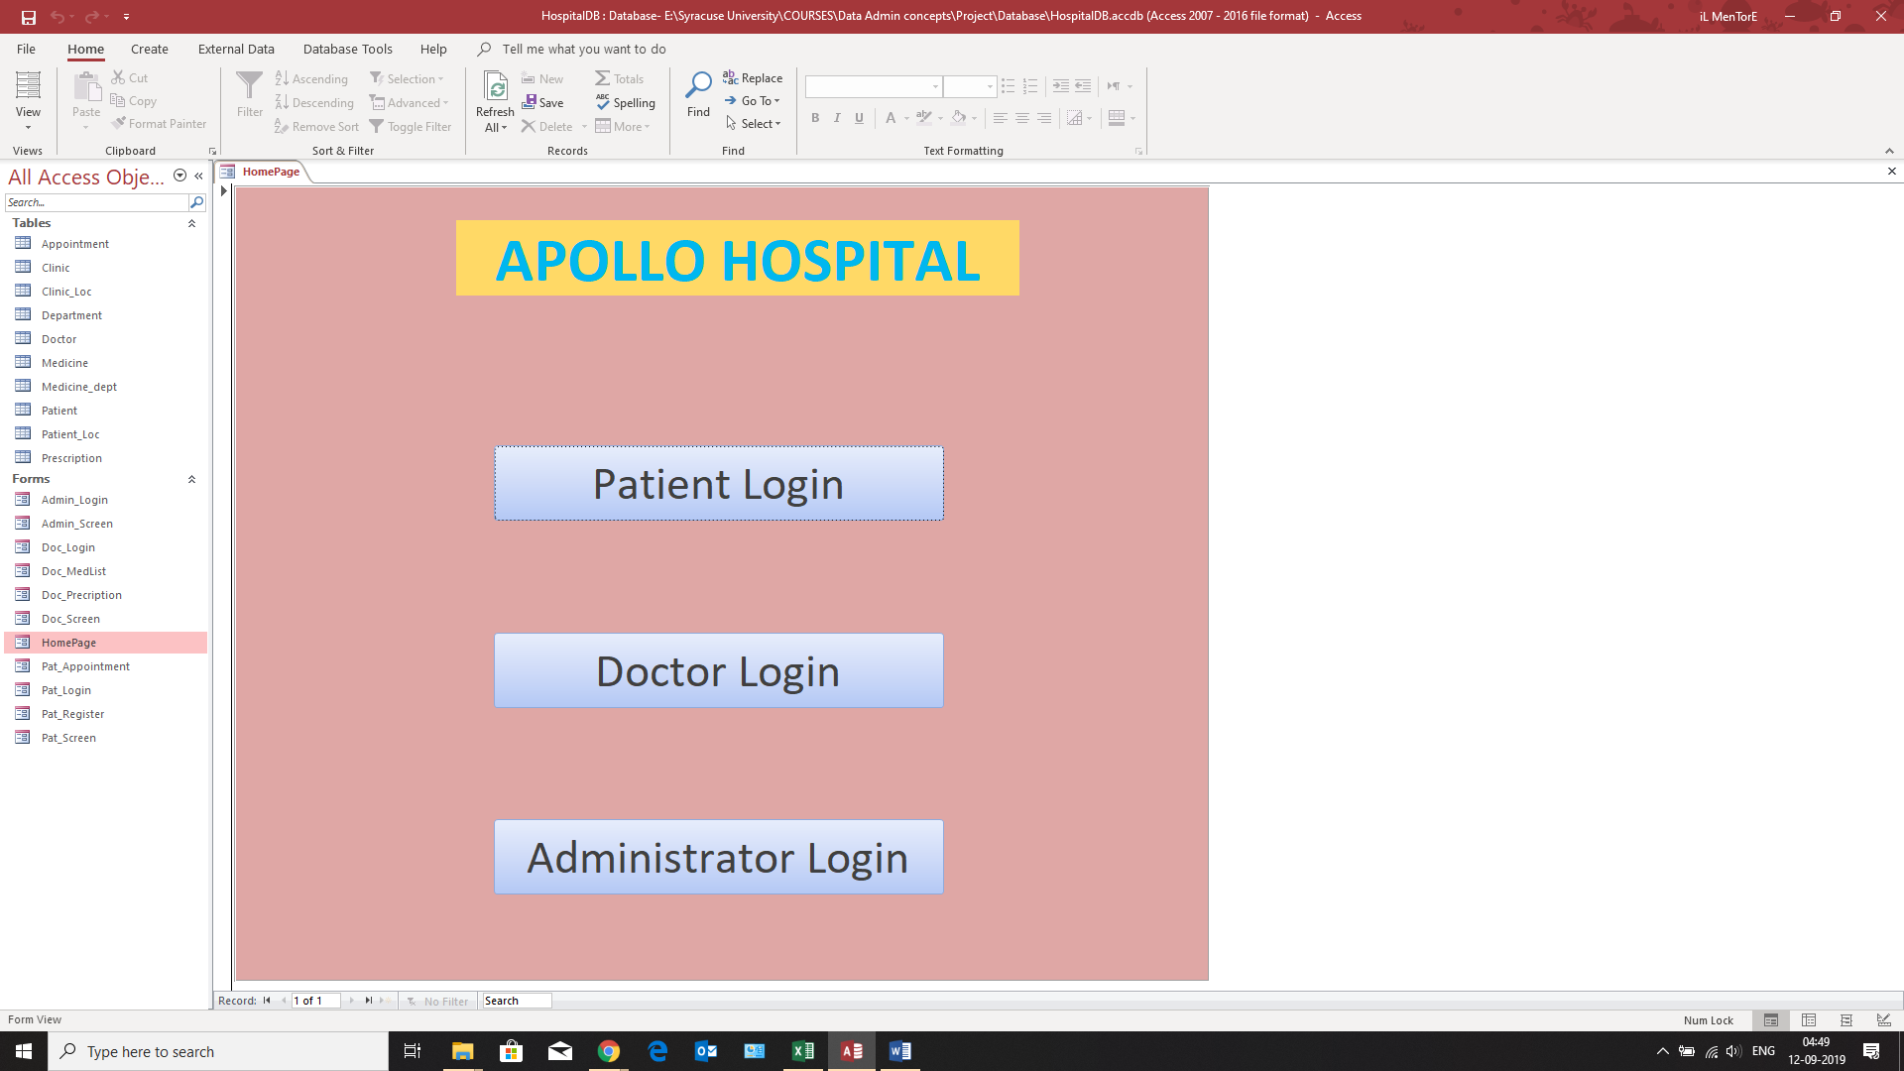

**Patient Login**

When the patient tries to access the log in screen by clicking “Patient Login”, he is greeted with this screen

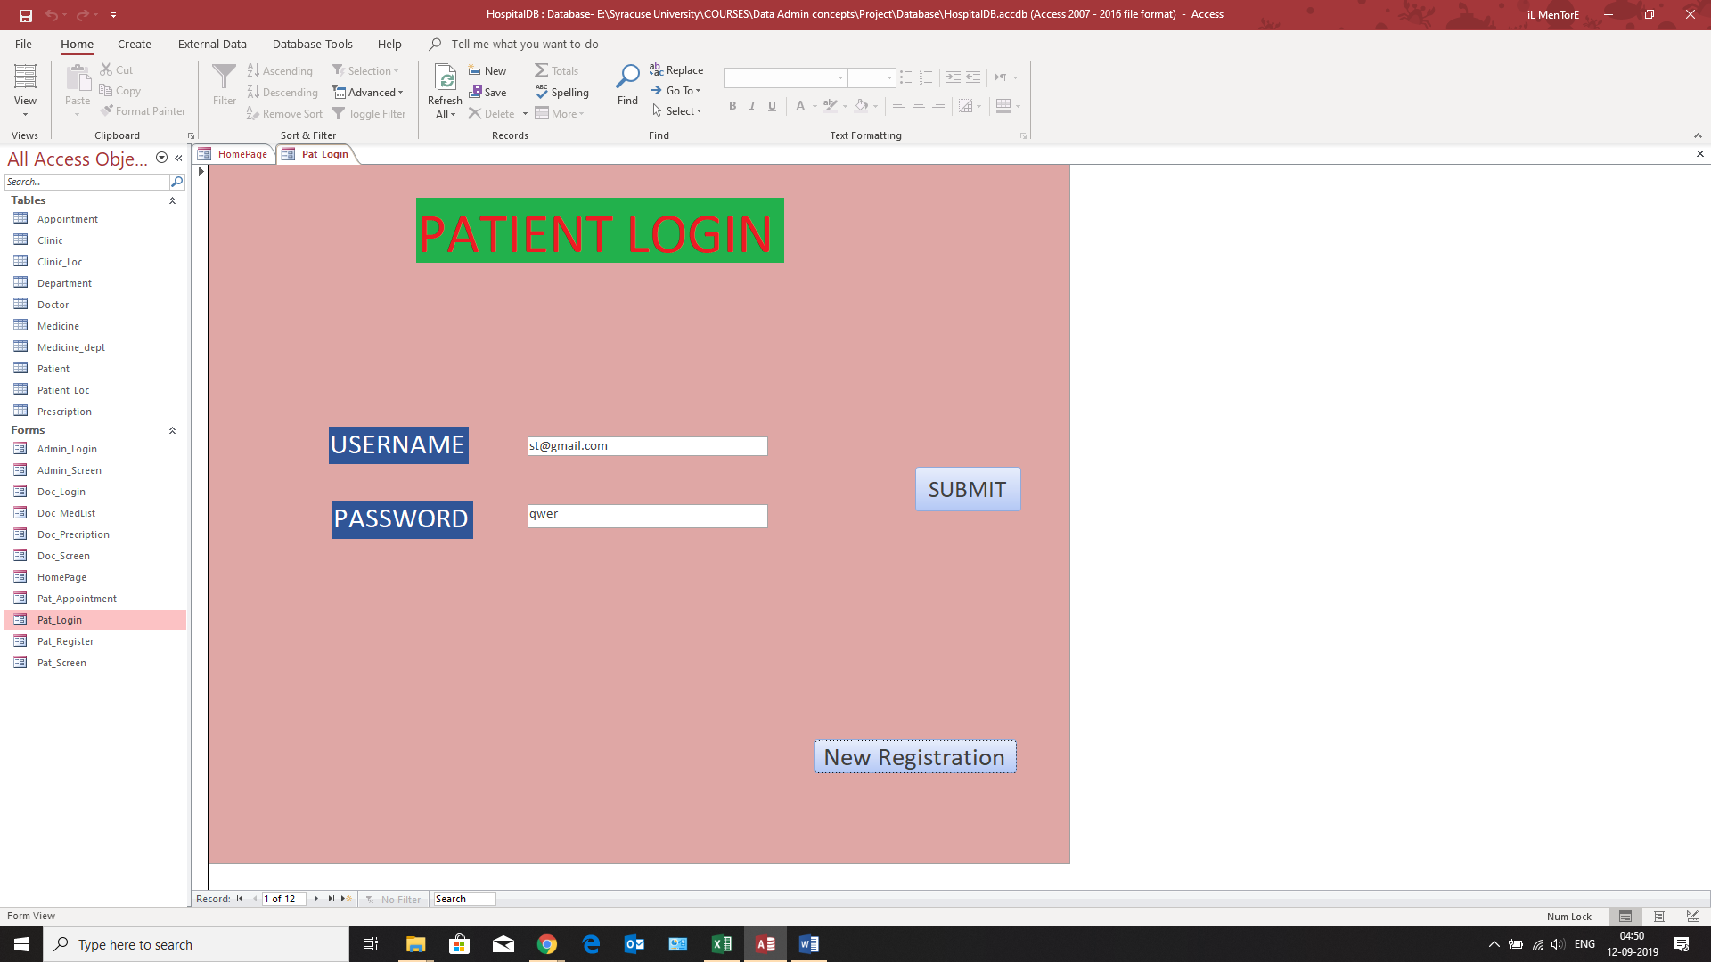

If the patient wants to register and create an account, by clicking on “New registration”, he is able to sign up on this portal.

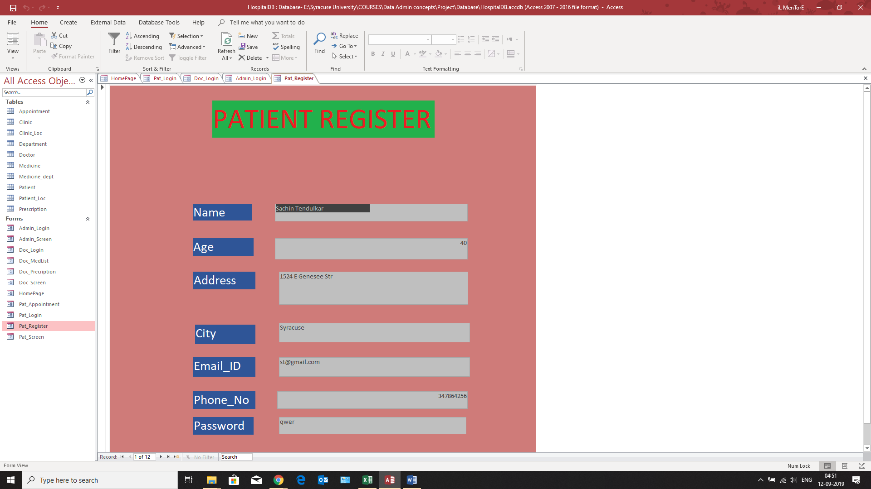

If the patient uses his credentials to log in, he is greeted by the following page where he is able to make an appointment, check out the appointment history and update location

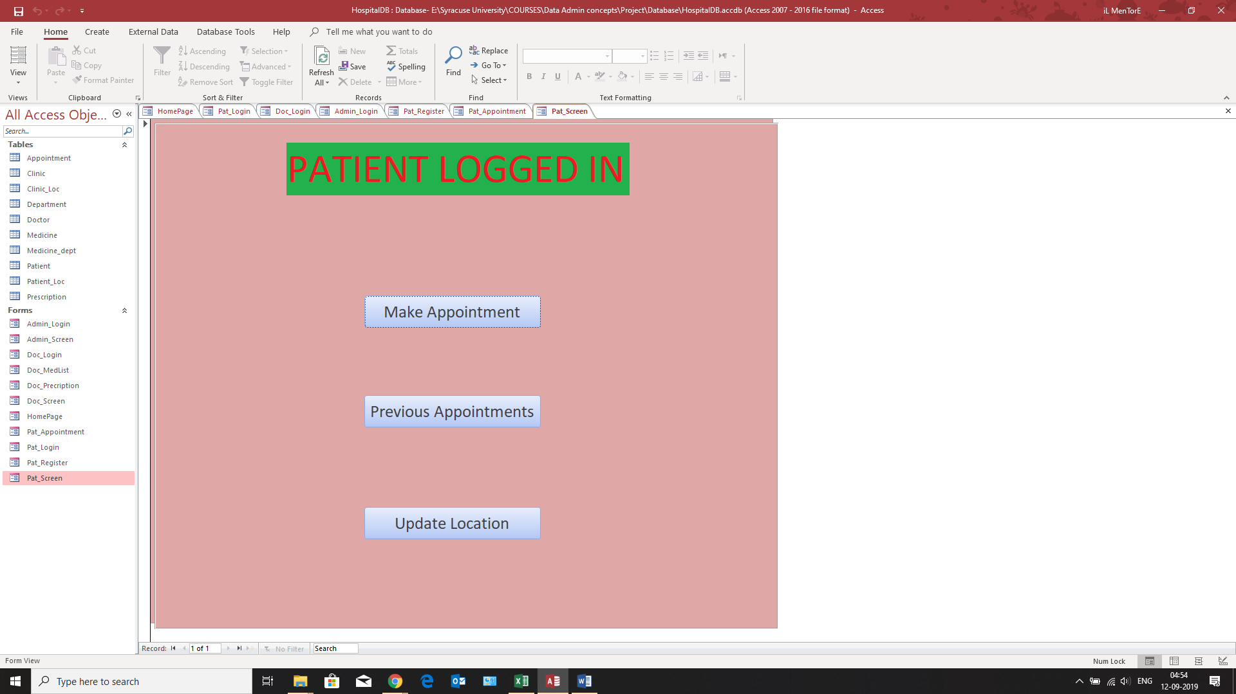

If the person clicks on “Make an appointment”, the following screen turns up

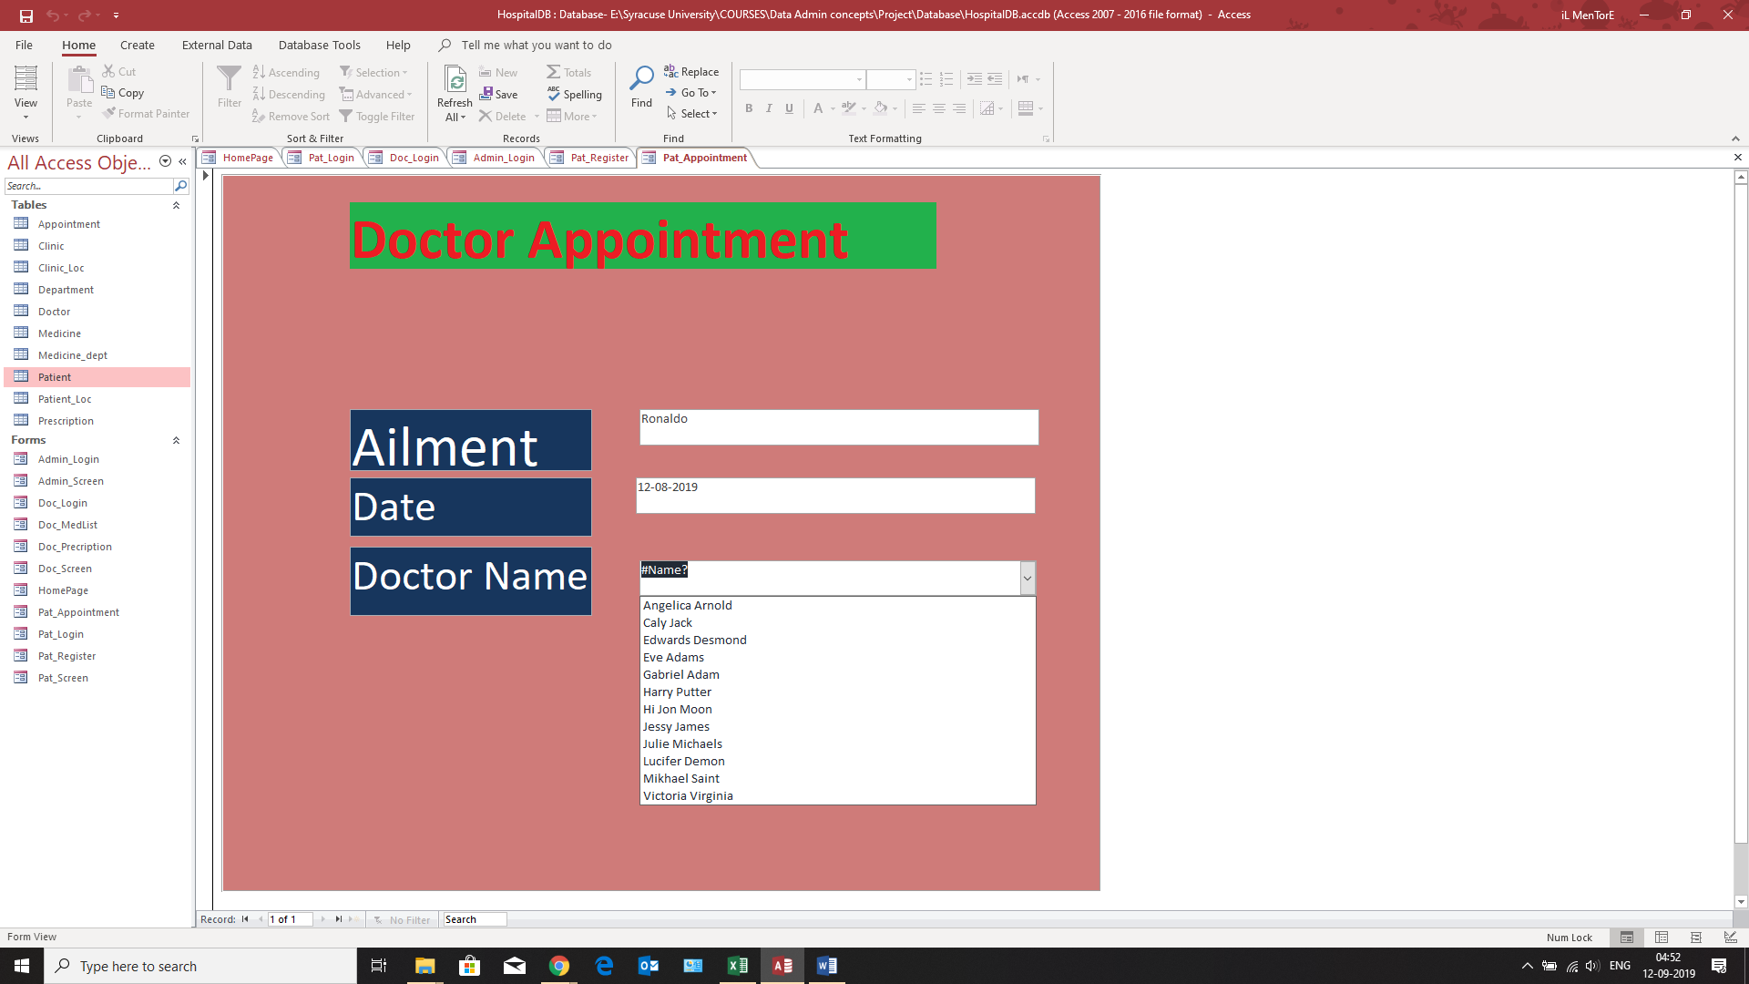

**Doctor Login**

If the Doctor wishes to log in to the portal, he sees this page

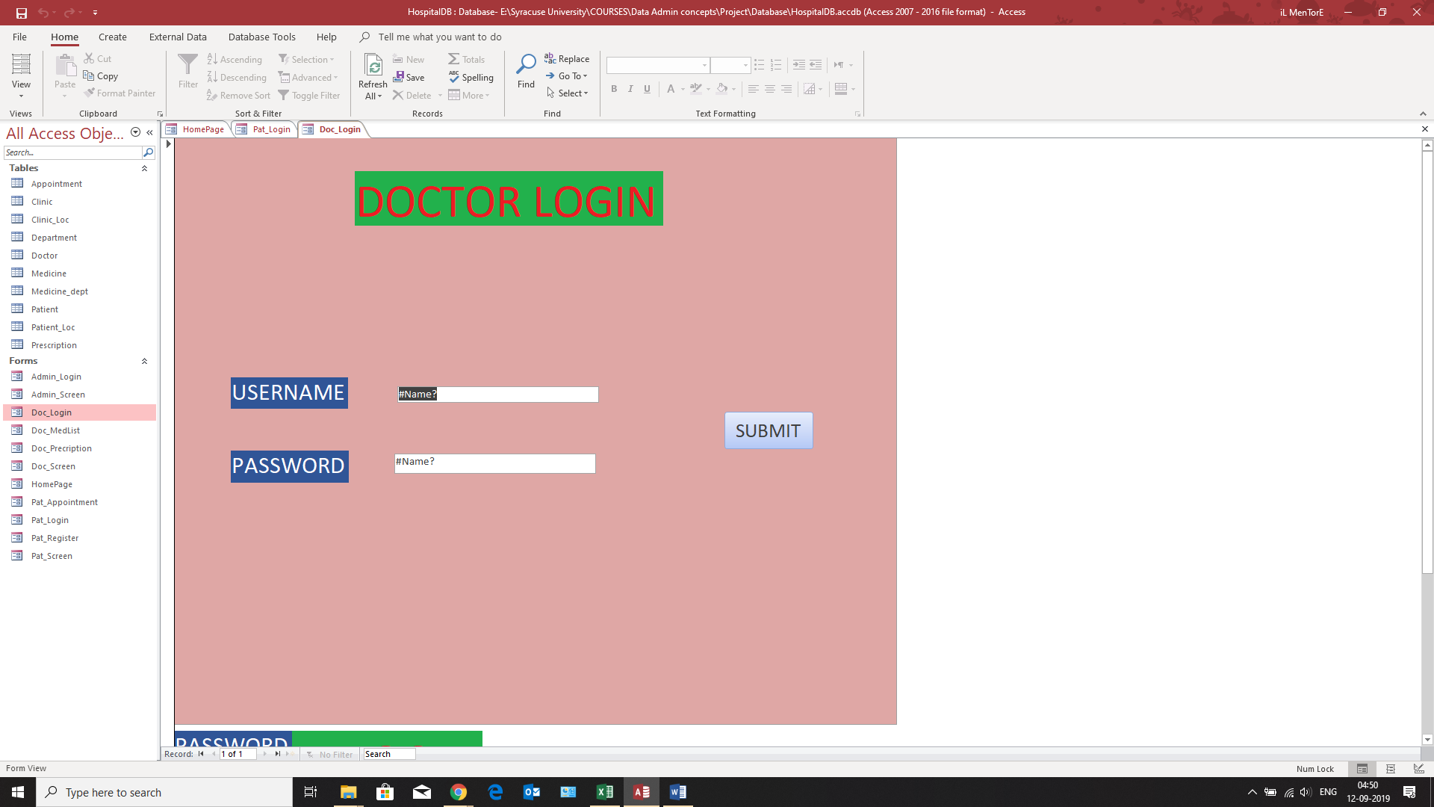

After logging in, the doctor can choose an option from making a prescription, checking the patient list, looking at the appointment list and checking the list of medicines in the inventory

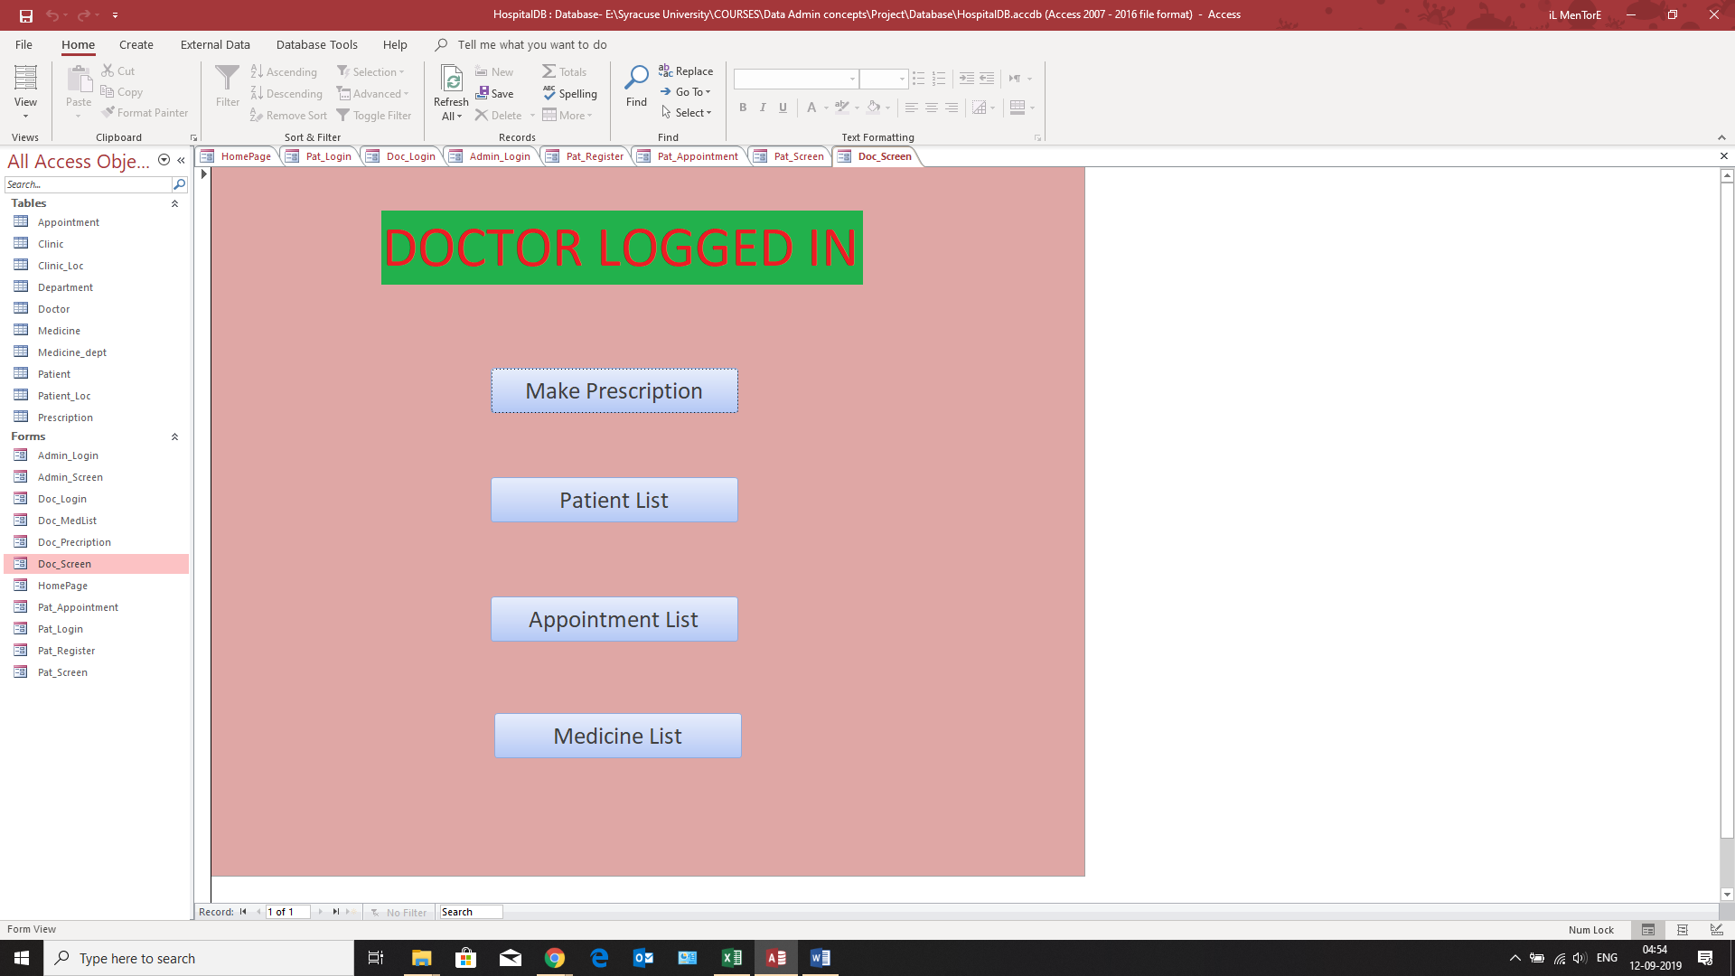

After selecting the option of making an prescription, he sees the following page

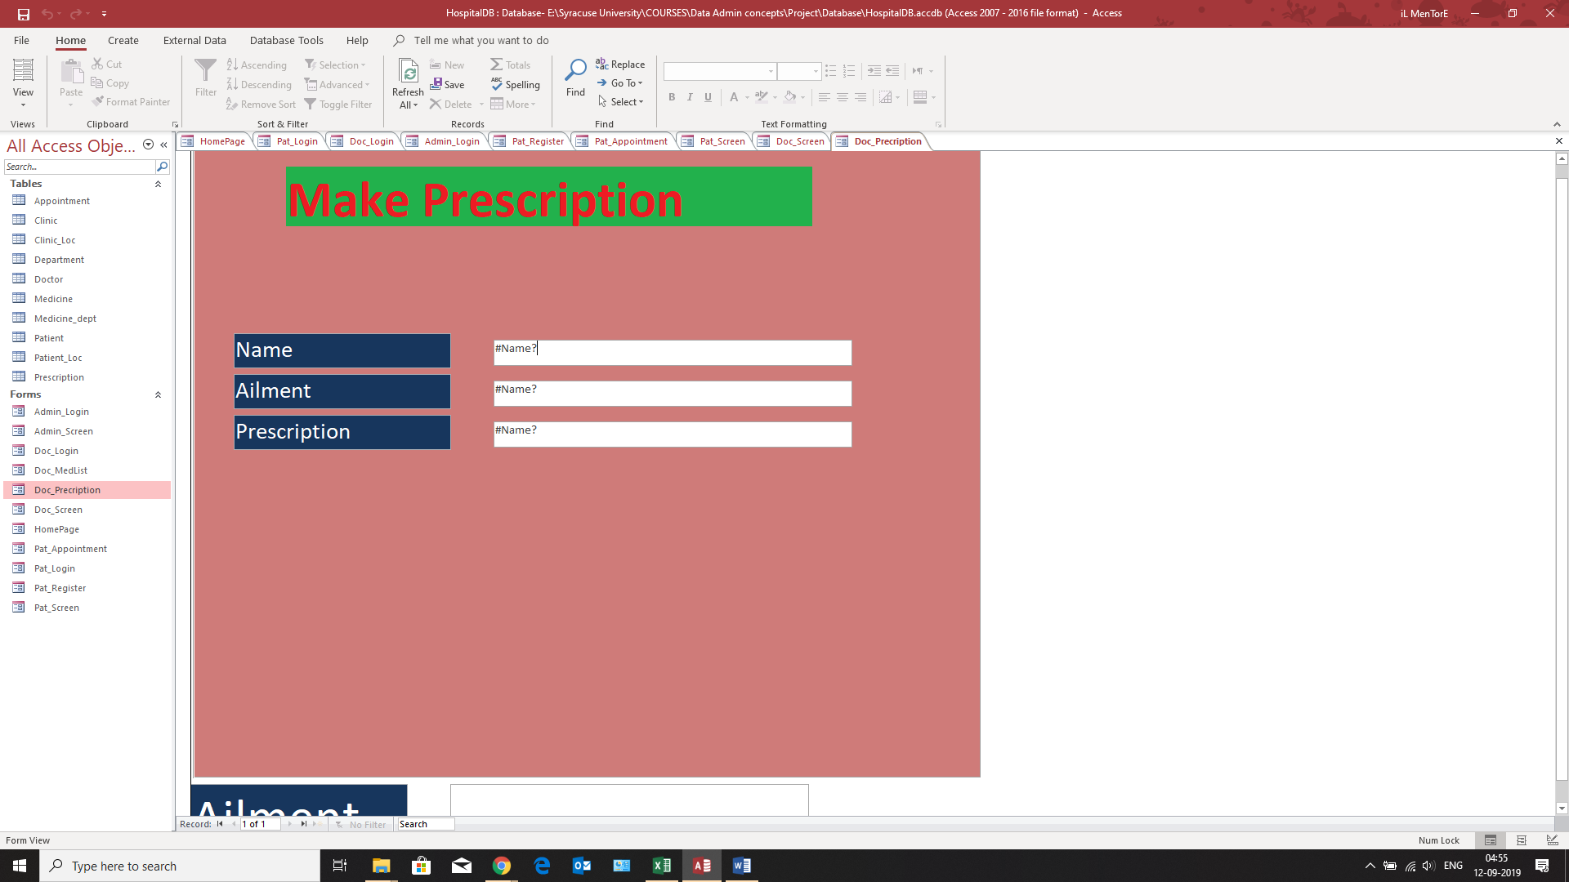

After selecting the option of checking the medicine list, the doctor comes across this screen

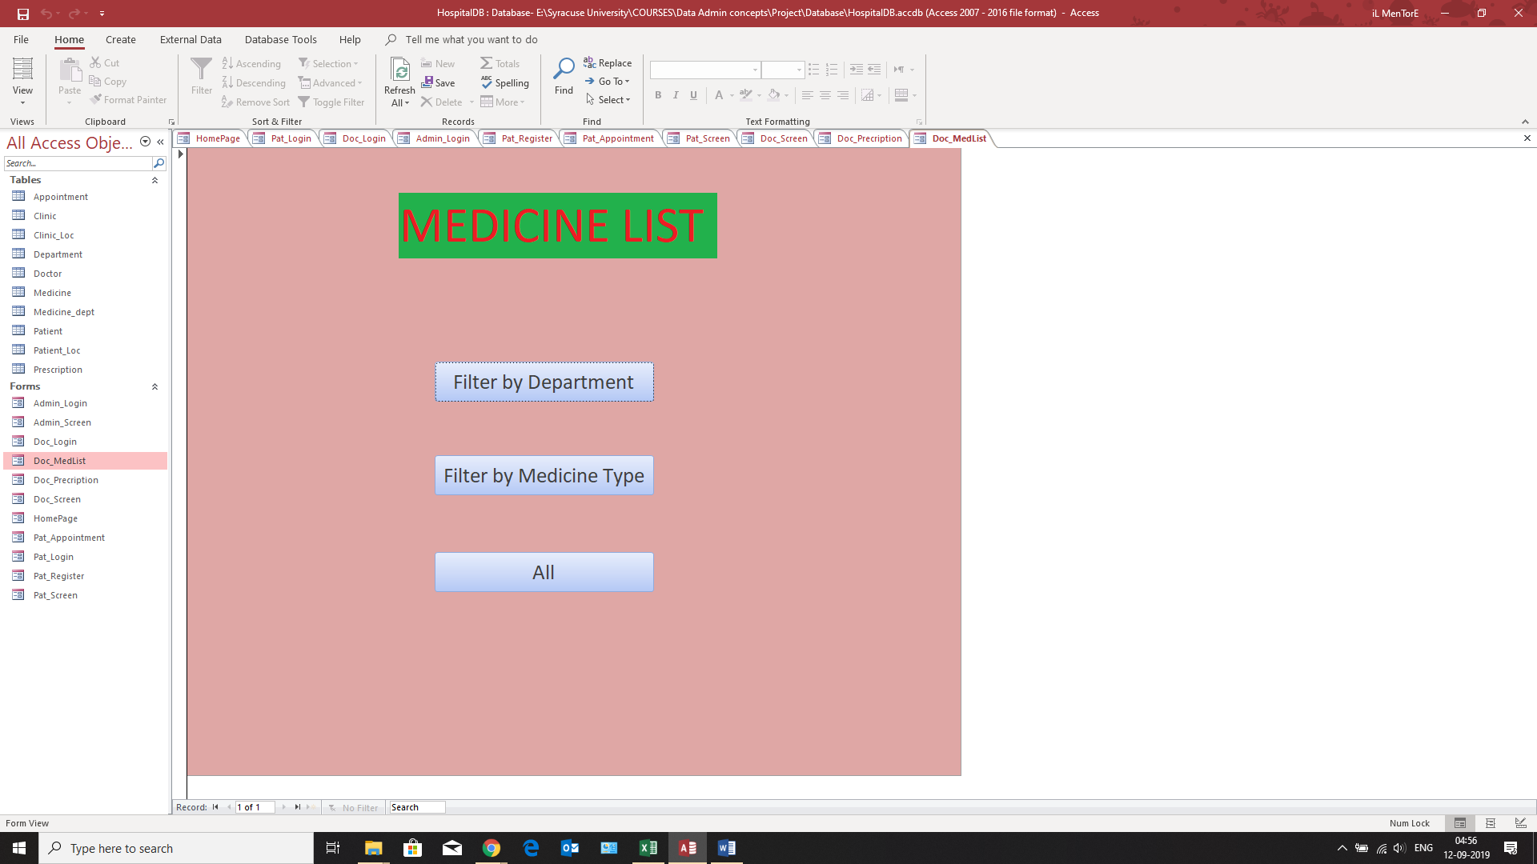

**Administrator Login**

The administrator is only one and can check the status as well as can add a doctor to the system

He/She comes across this screen after logging in.

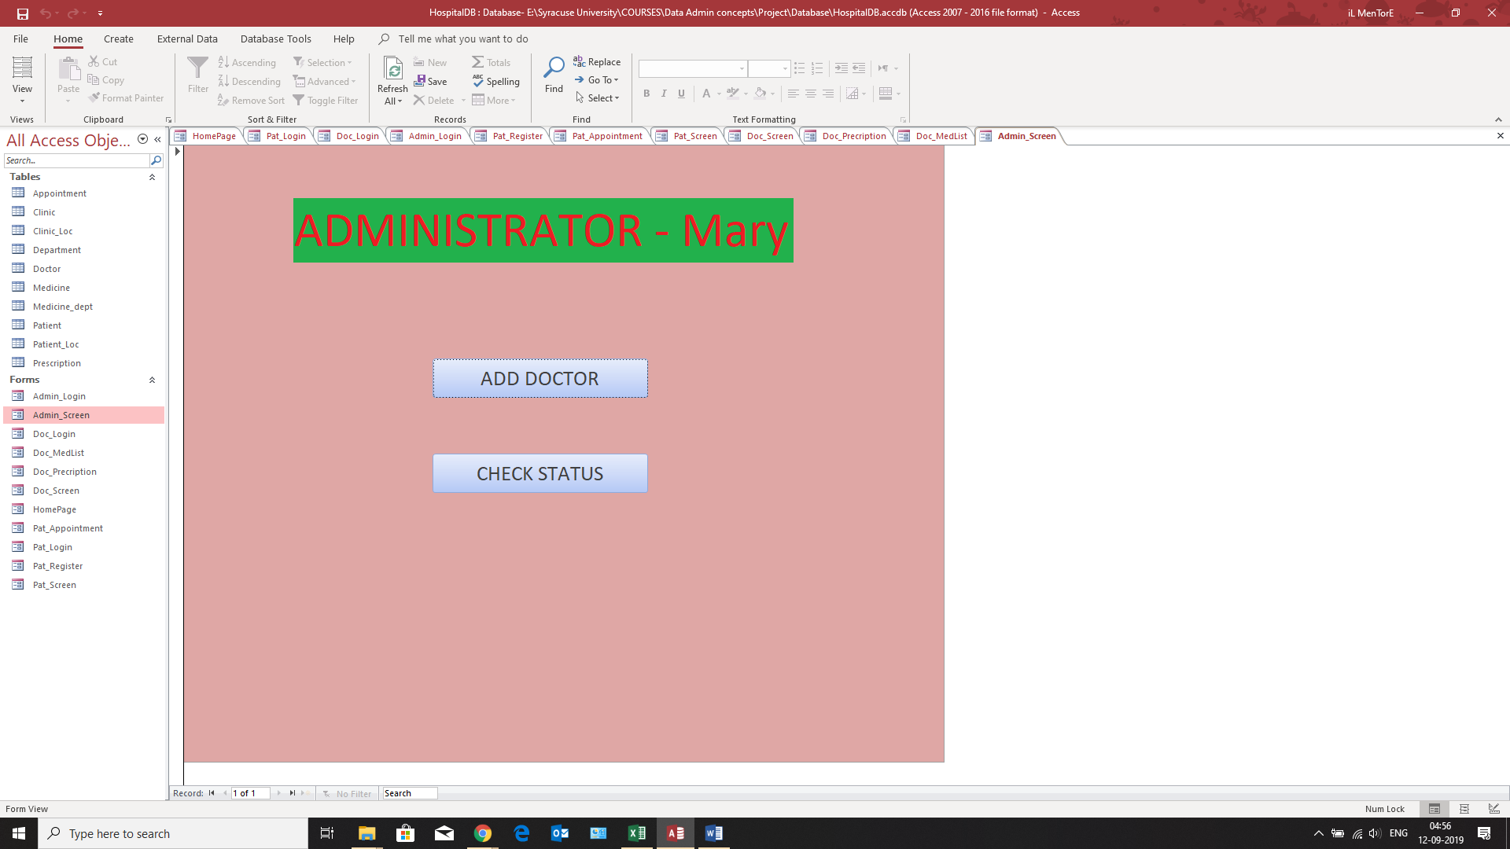

**Procedure**

A procedure is a method which is programmed to perform the same kind of work again and again. We have created the following procedure to extract doctors according to their departments.

**Trigger**

We have added the following trigger to the database:

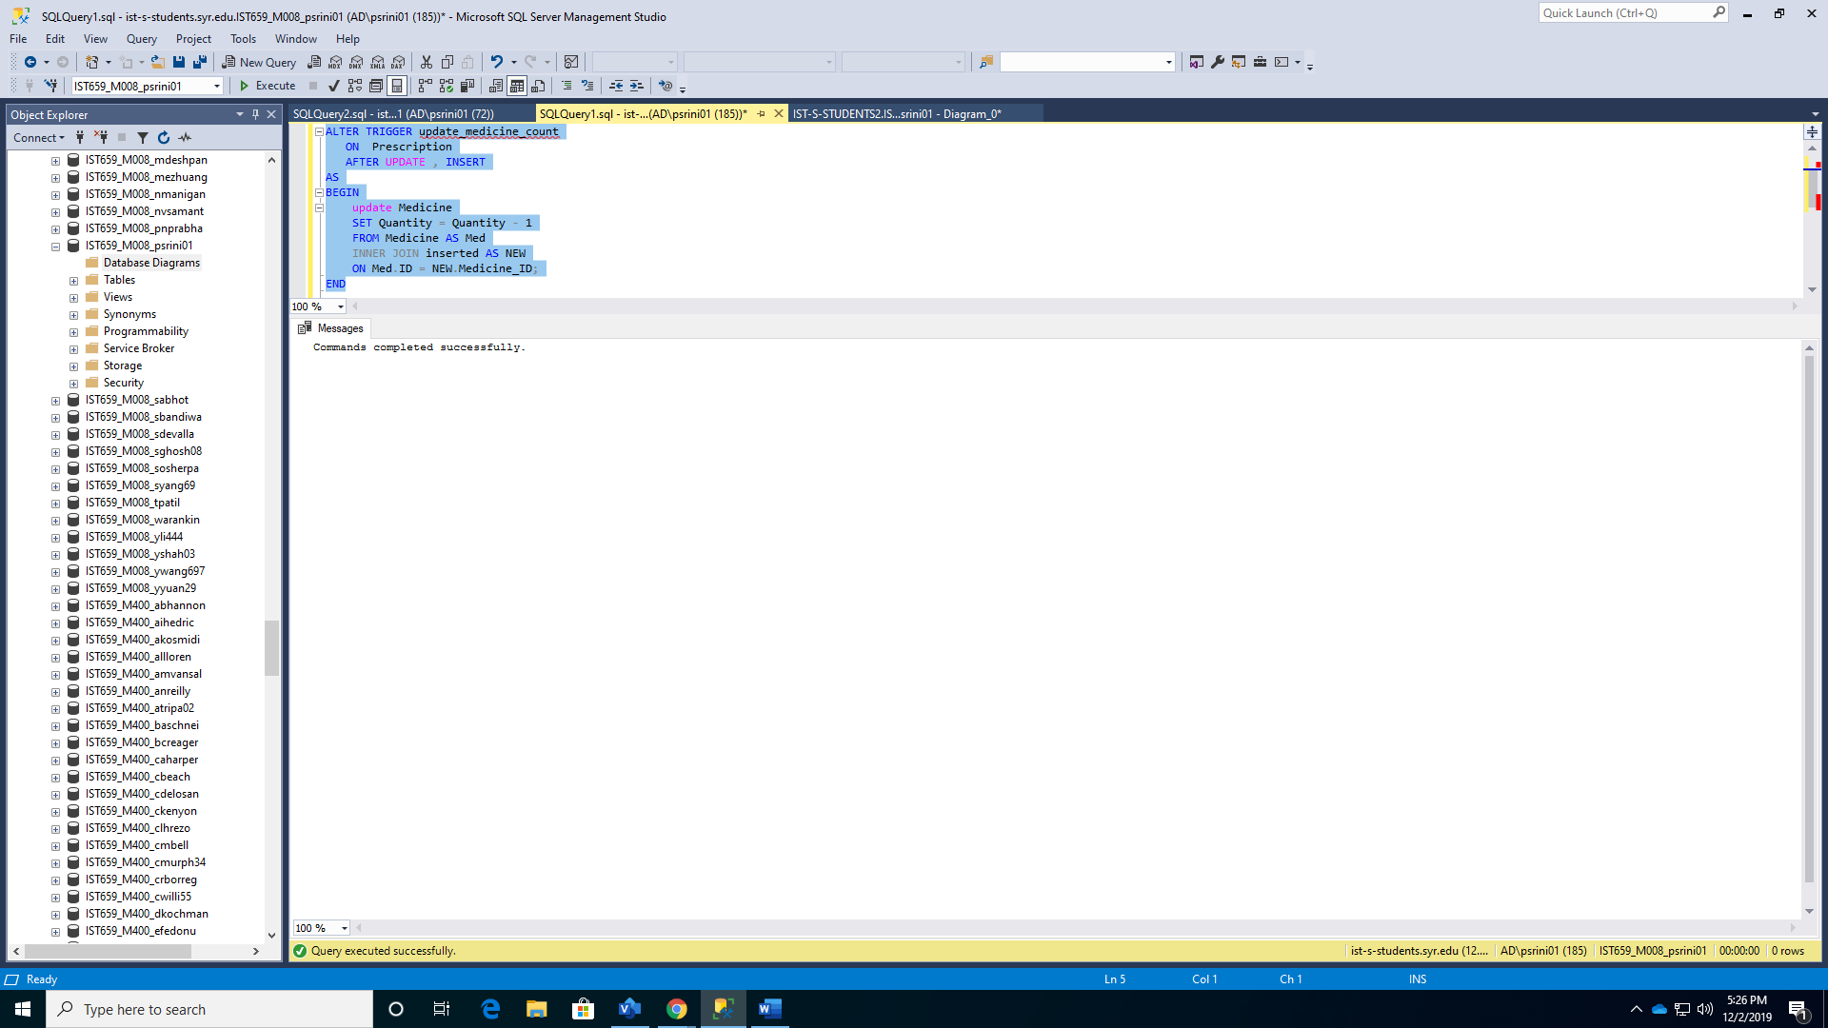

Before the trigger is applied, if we select values from the medicine table, we get the following result

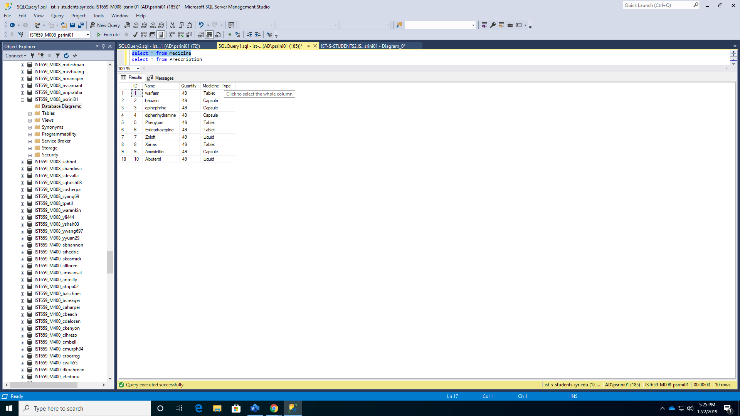

Prescription table is inserted with the following value

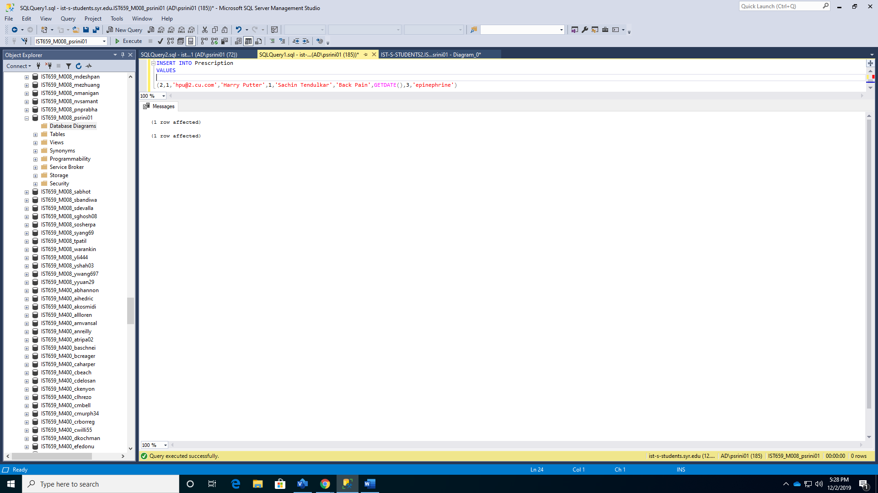

The prescription table is selected after the trigger is hit

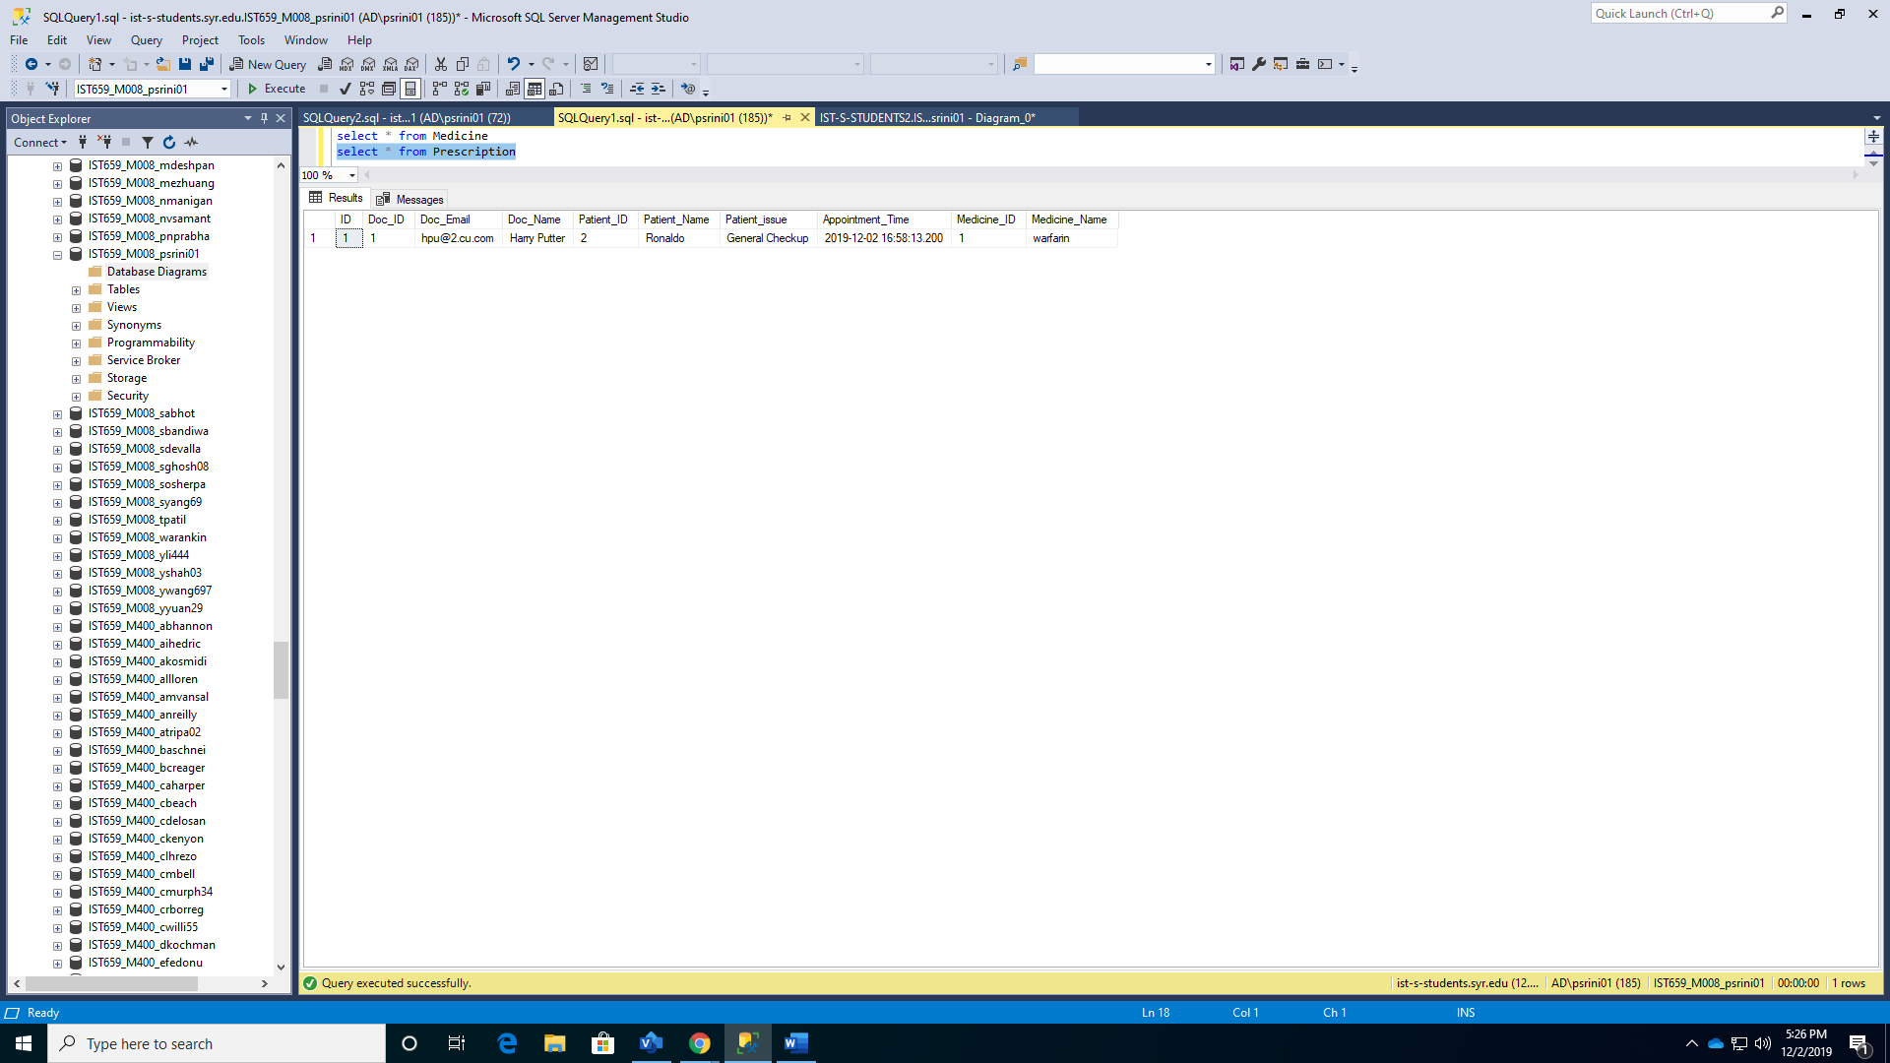

Medicine Table with Quantity AFTER Prescription table is updated

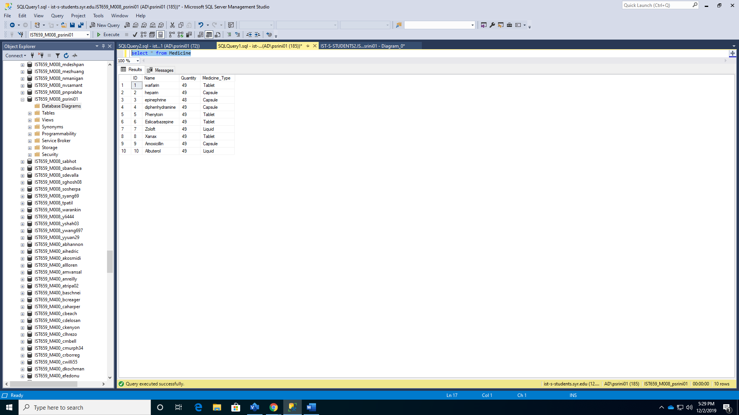

**Reports**

With respect to 2nd business question, how to find doctors in a department.

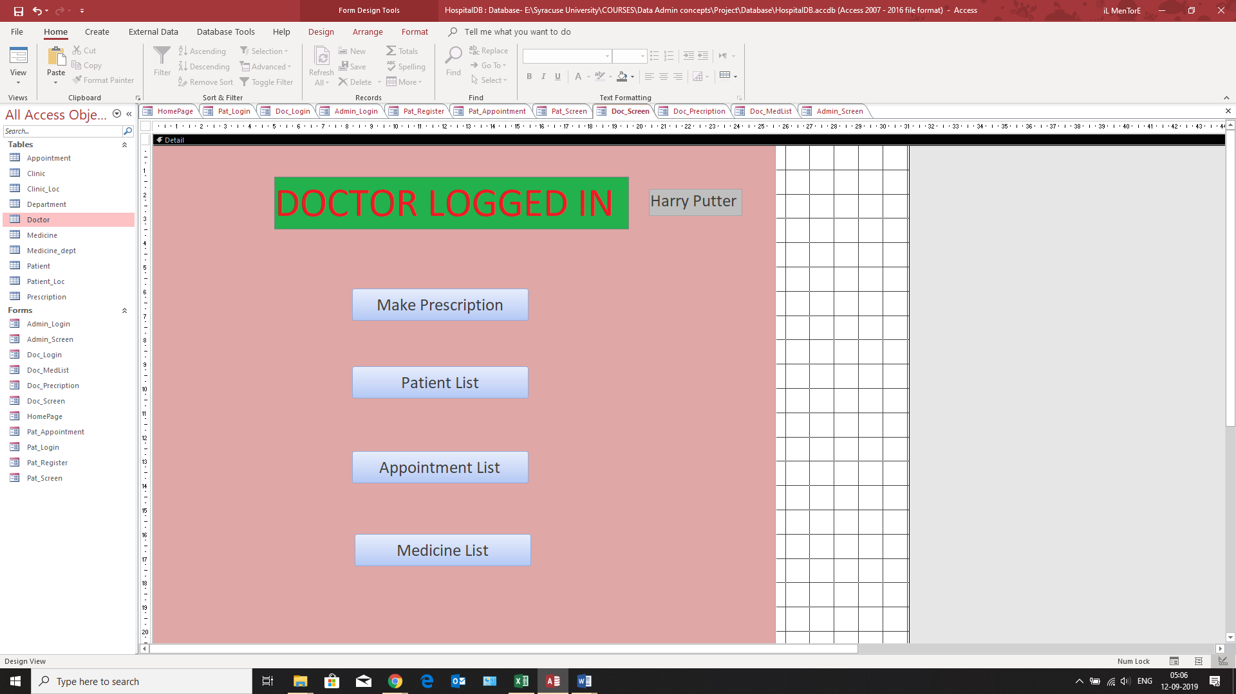

The report has been posted below:

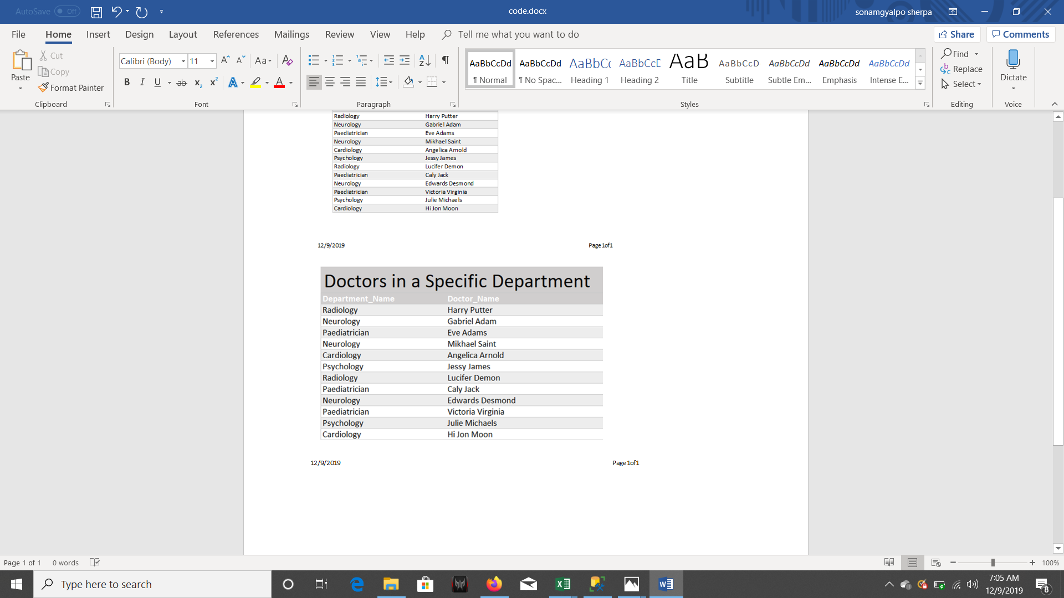

The patient wants to know the location of a clinic in the city

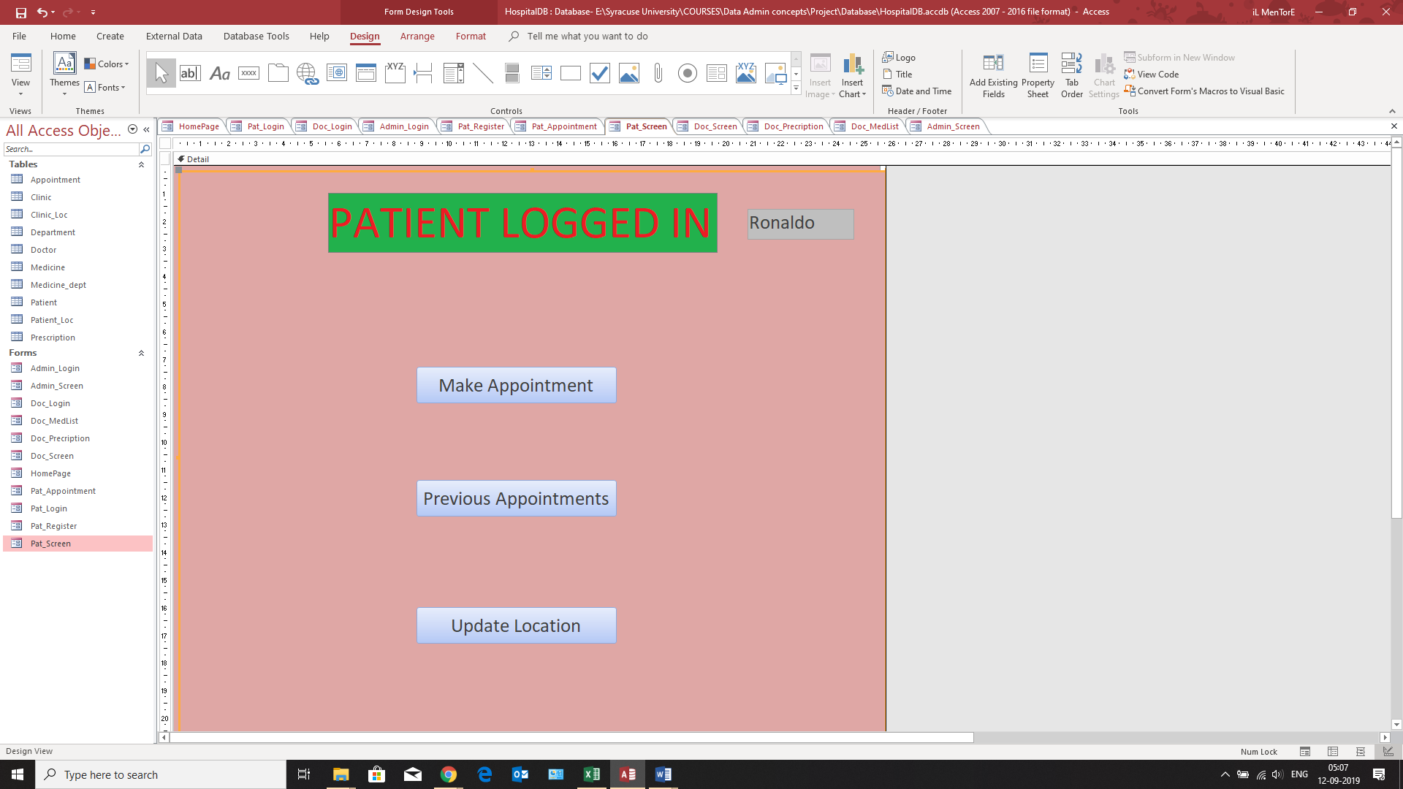

The report has been posted below:

